# Bootcamp 2020 Class 2: React App

**Bootcamp 2020 Class 2: React App** **1**

Part I - Create React Project using Create React App 2

Part II - Open the Project with VS Code 4

Part III - View the Project in the Browser 6

Part IV - Add Repository to GitHub with the CLI 9

Part V - Deploy React App to Surge with a GitHub Workflow 17

Part VI - Learn React 21

Part VII - Report Project Completed as an Issue 22

## Part I - Create React Project using Create React App

Step 1: Create a new local repository

First, I navigate to my local GitHub folder where all my local repositories are kept.

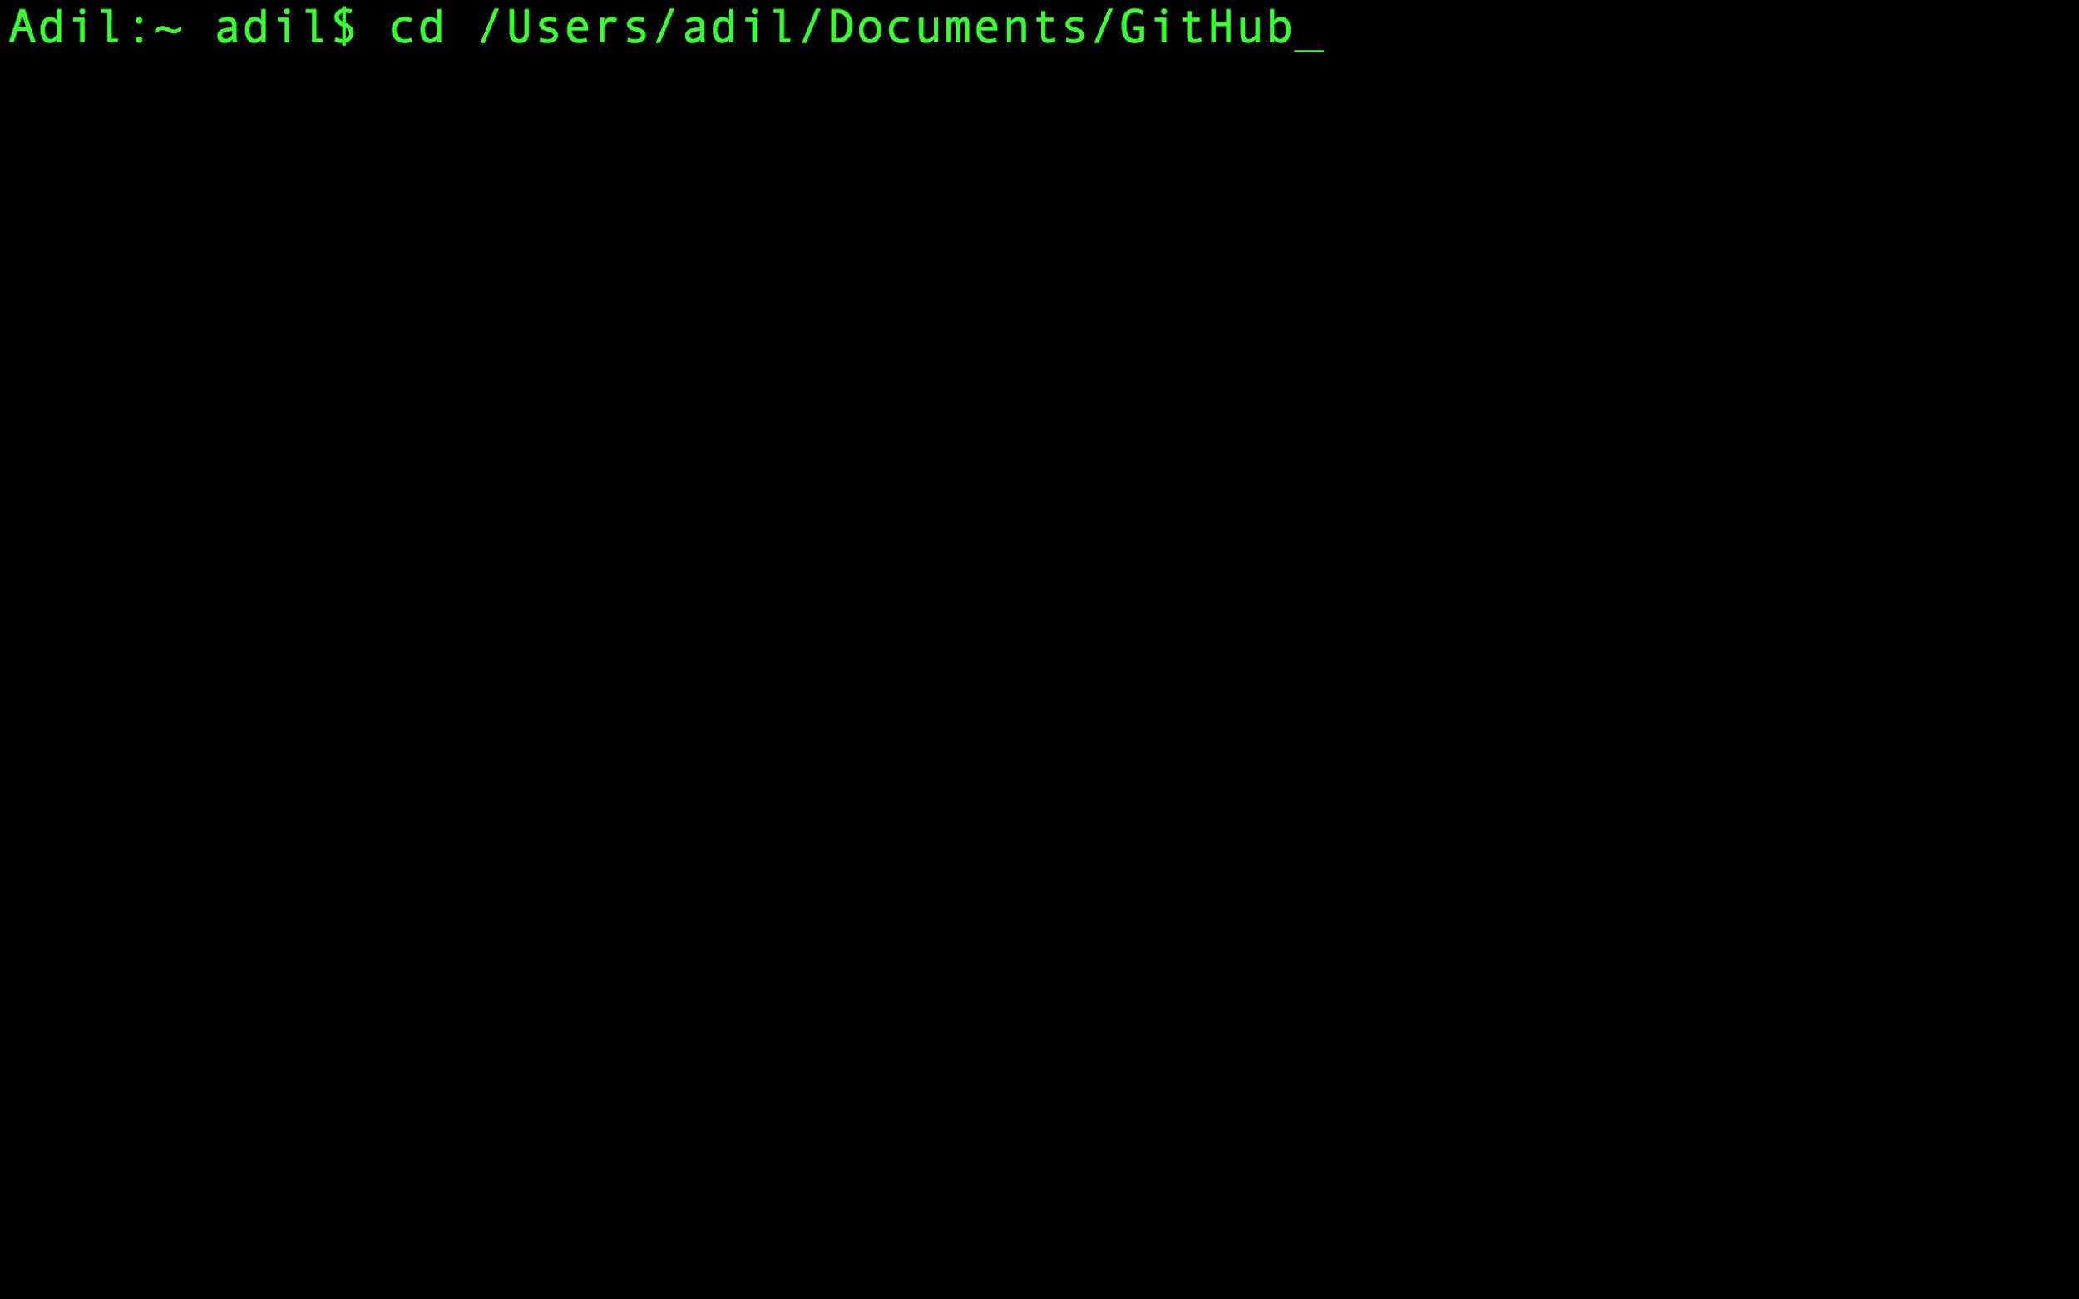

Now I create my local repository by creating my basic react application with:

npx create-react-app <app-name>

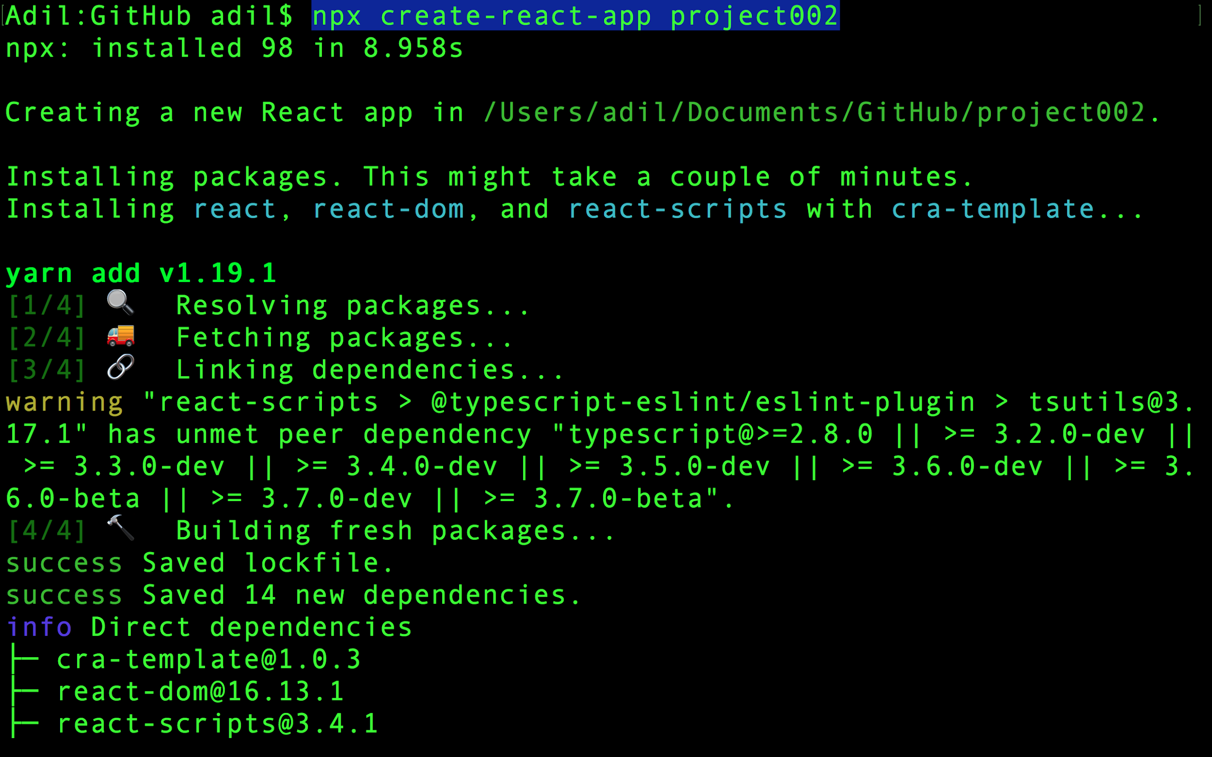

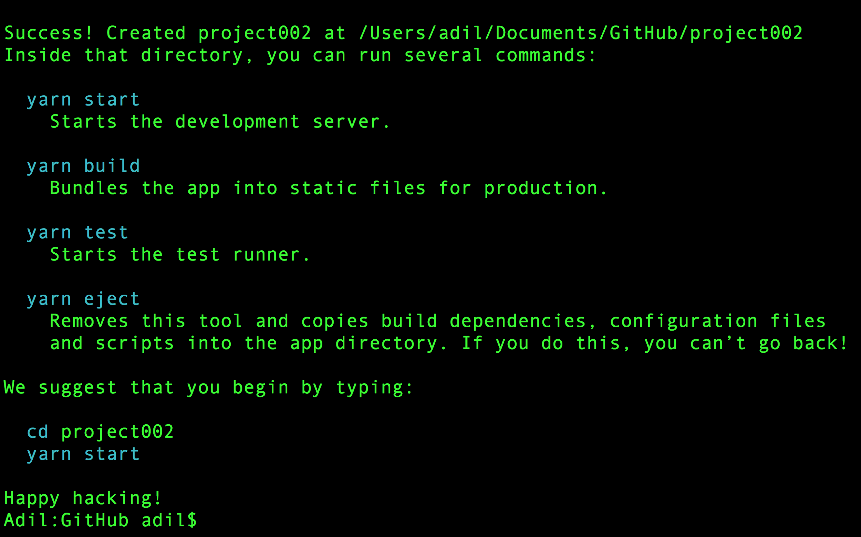

## Part II - Open the Project with VS Code

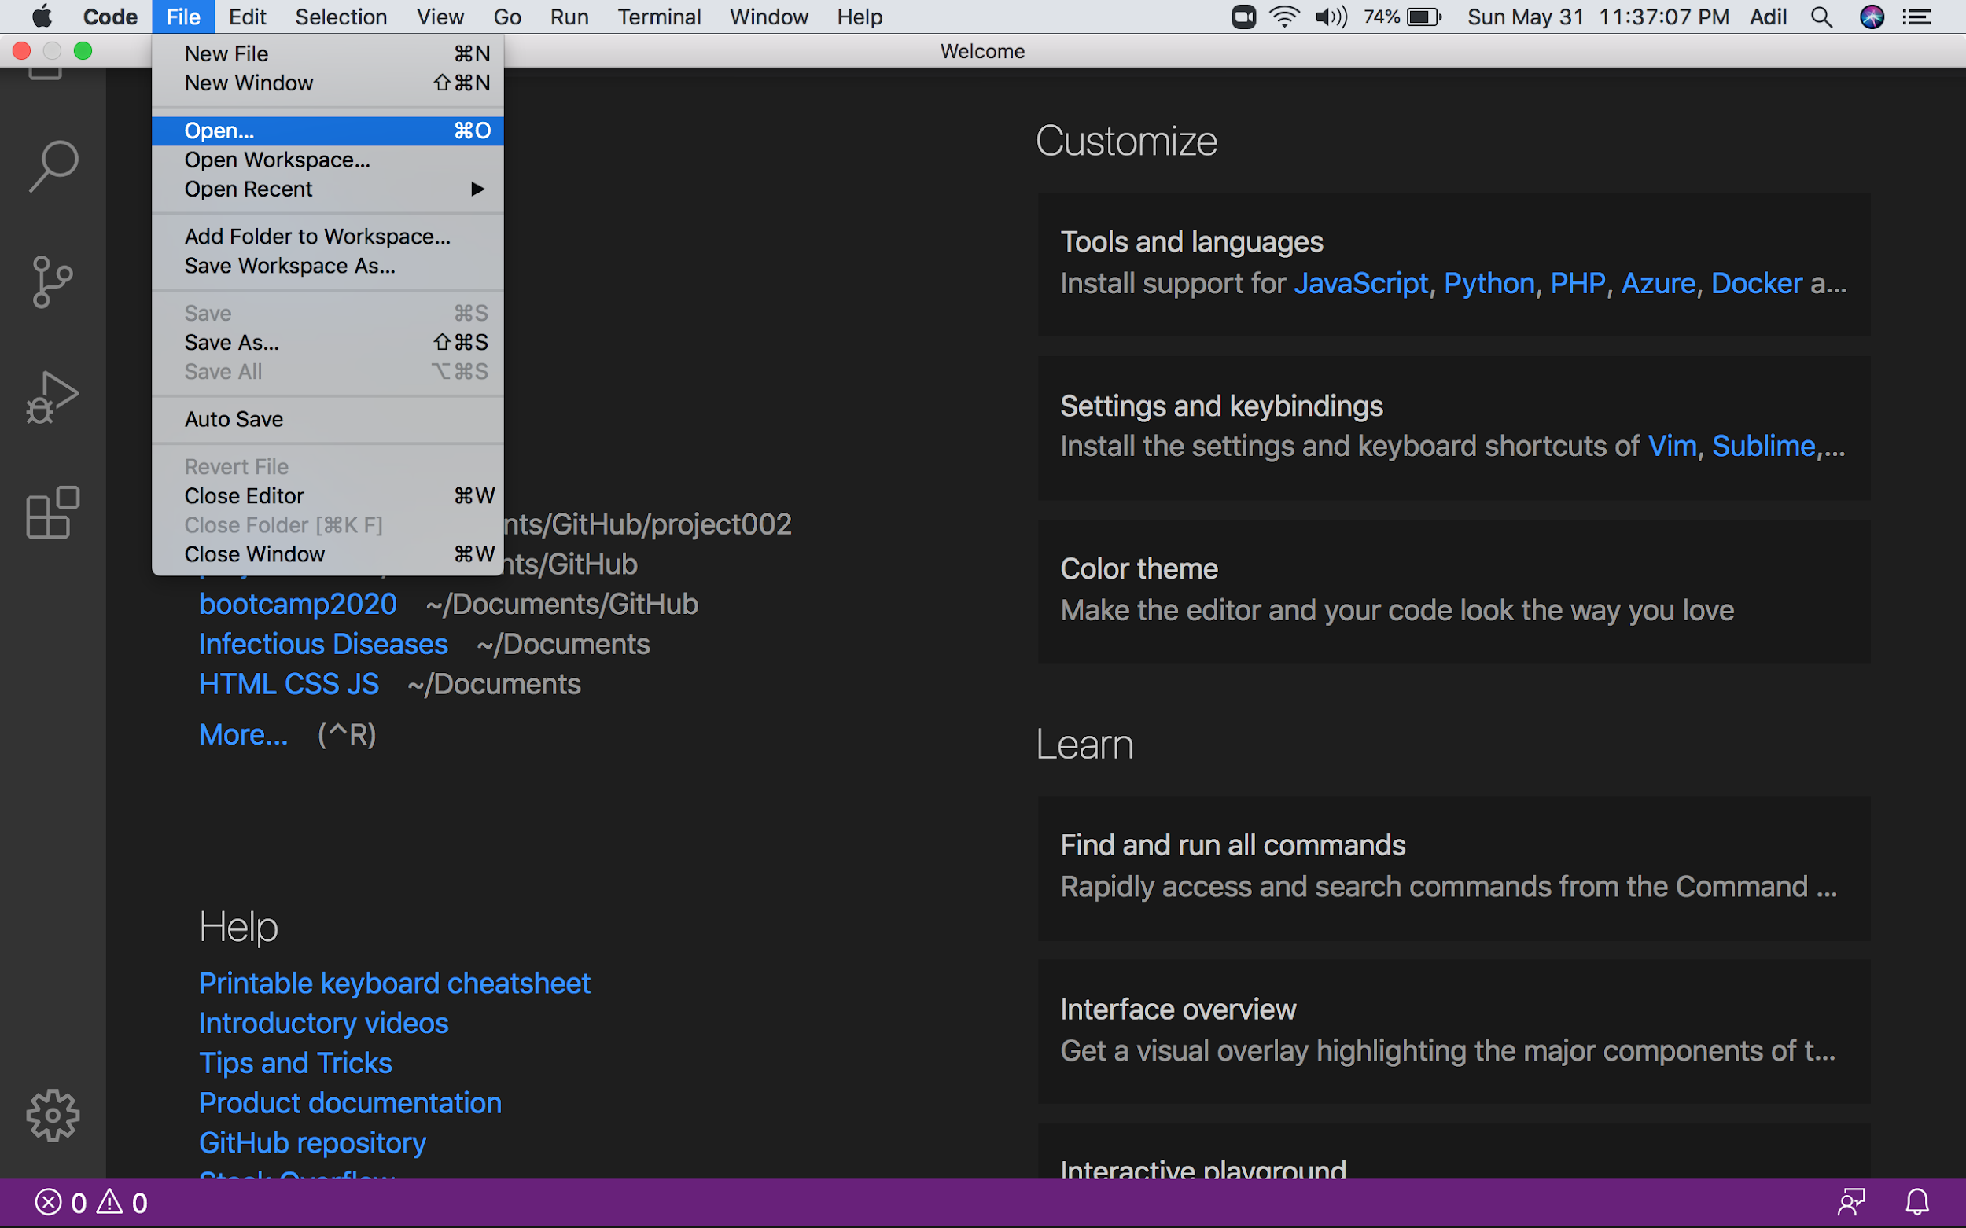

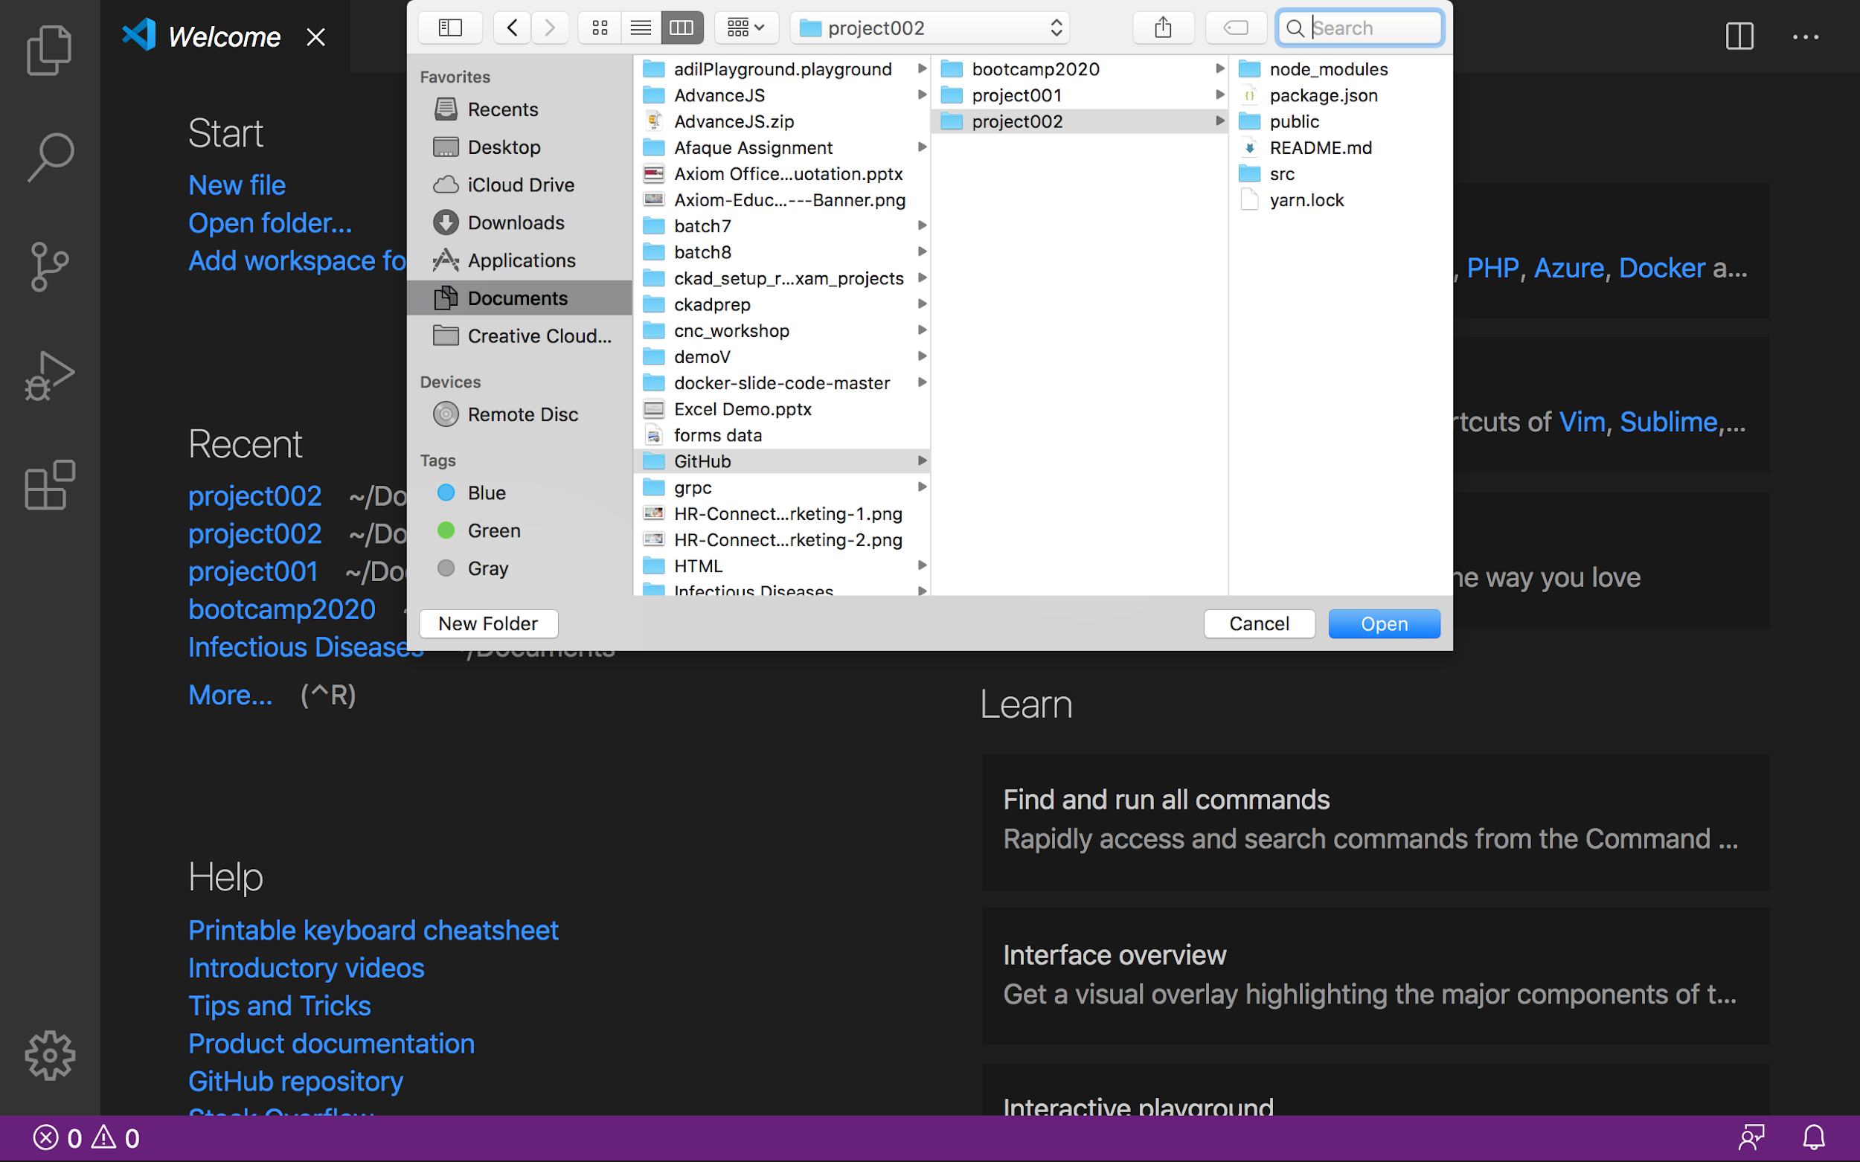

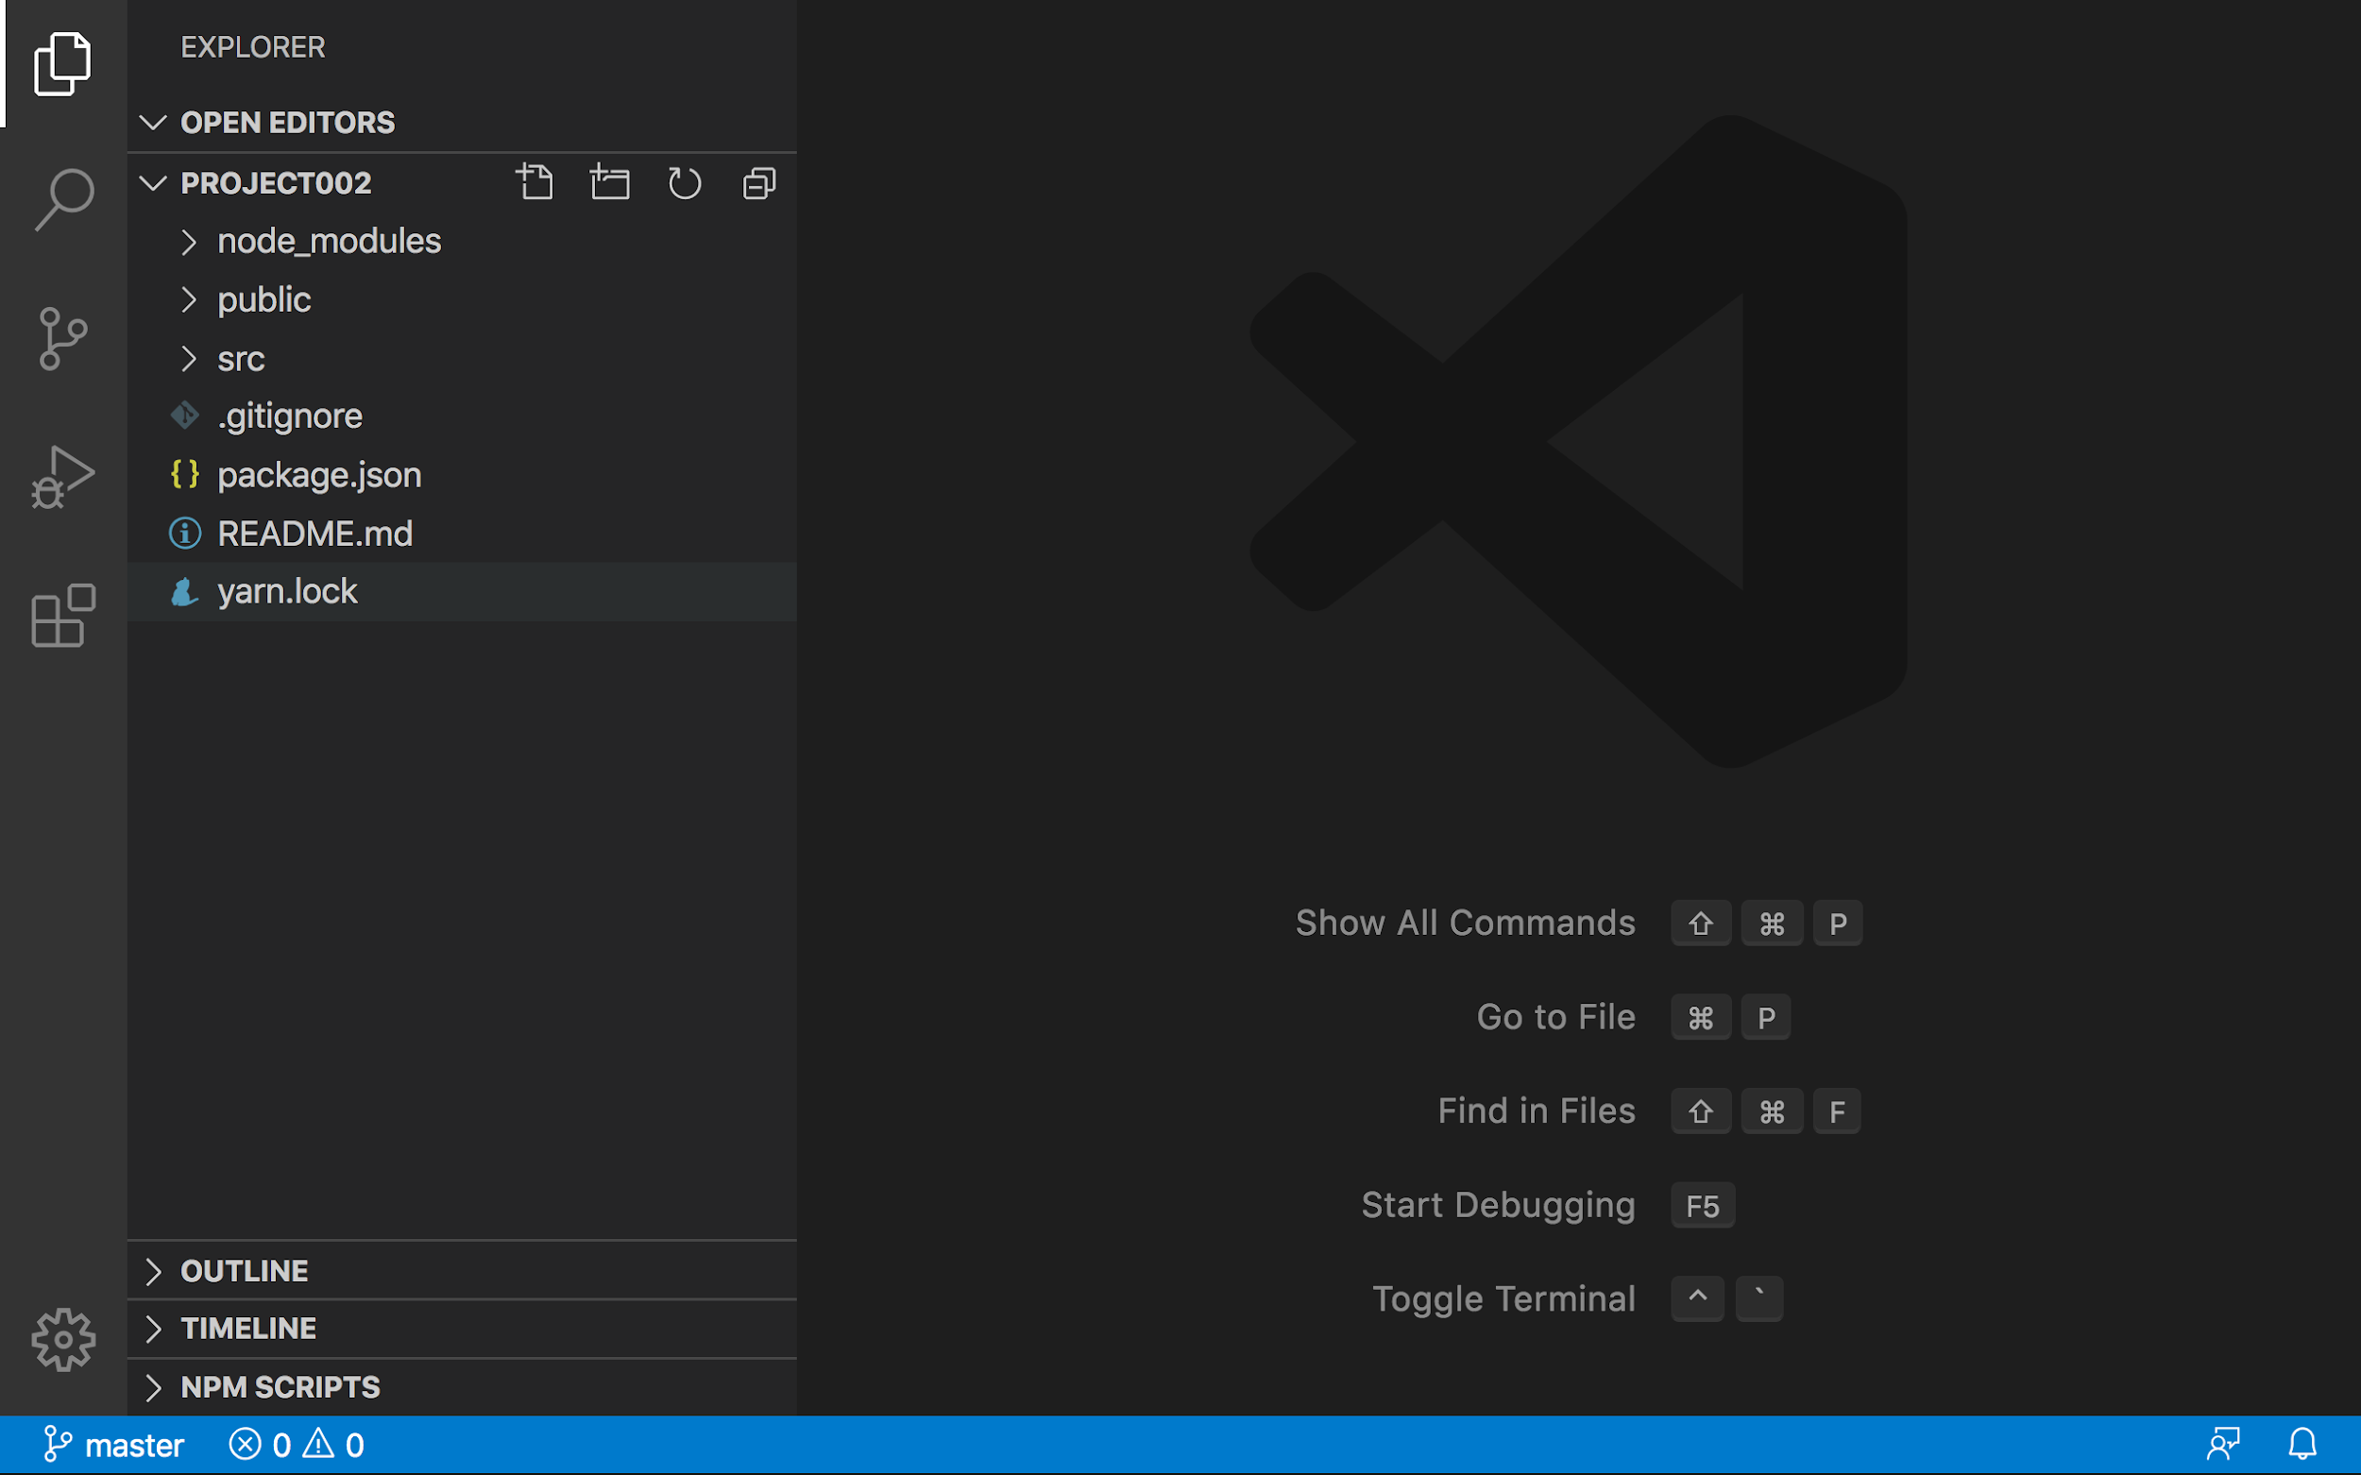

## Part III - View the Project in the Browser

First, let’s open the project in the terminal

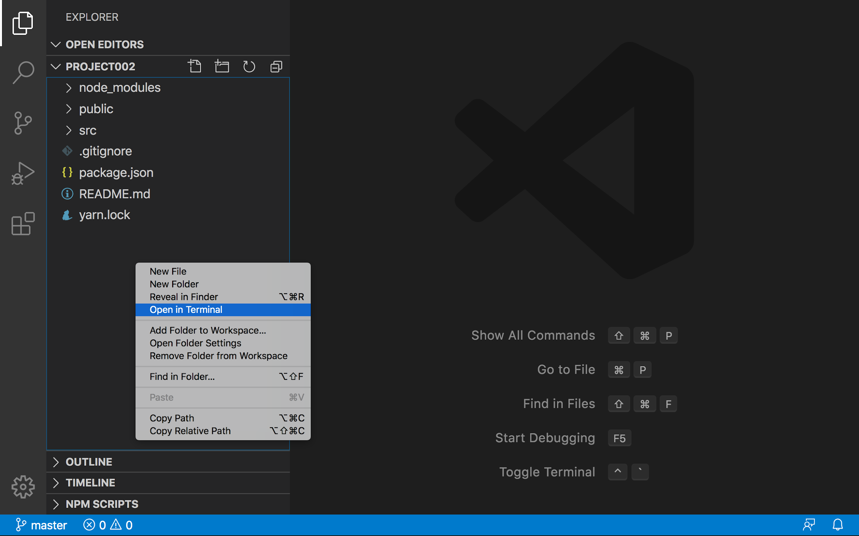

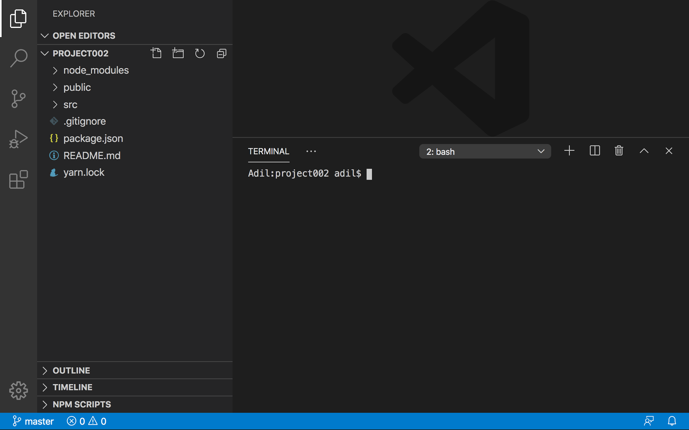

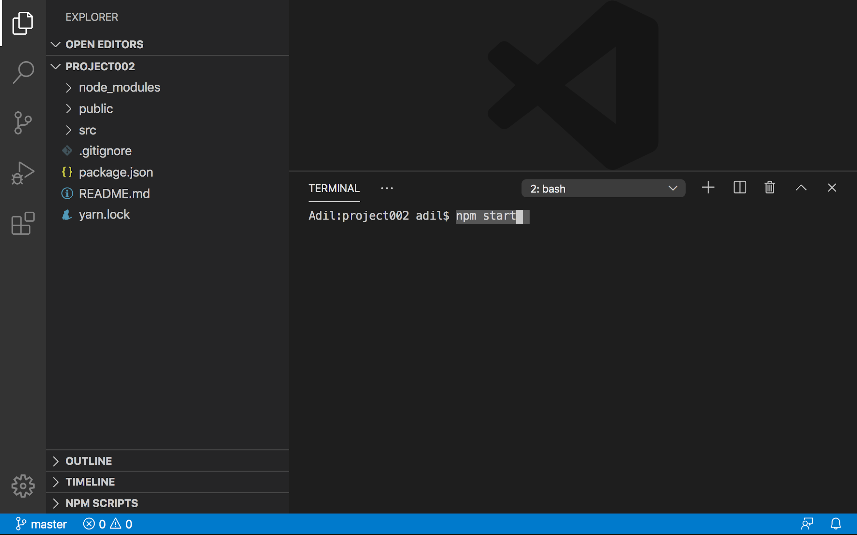

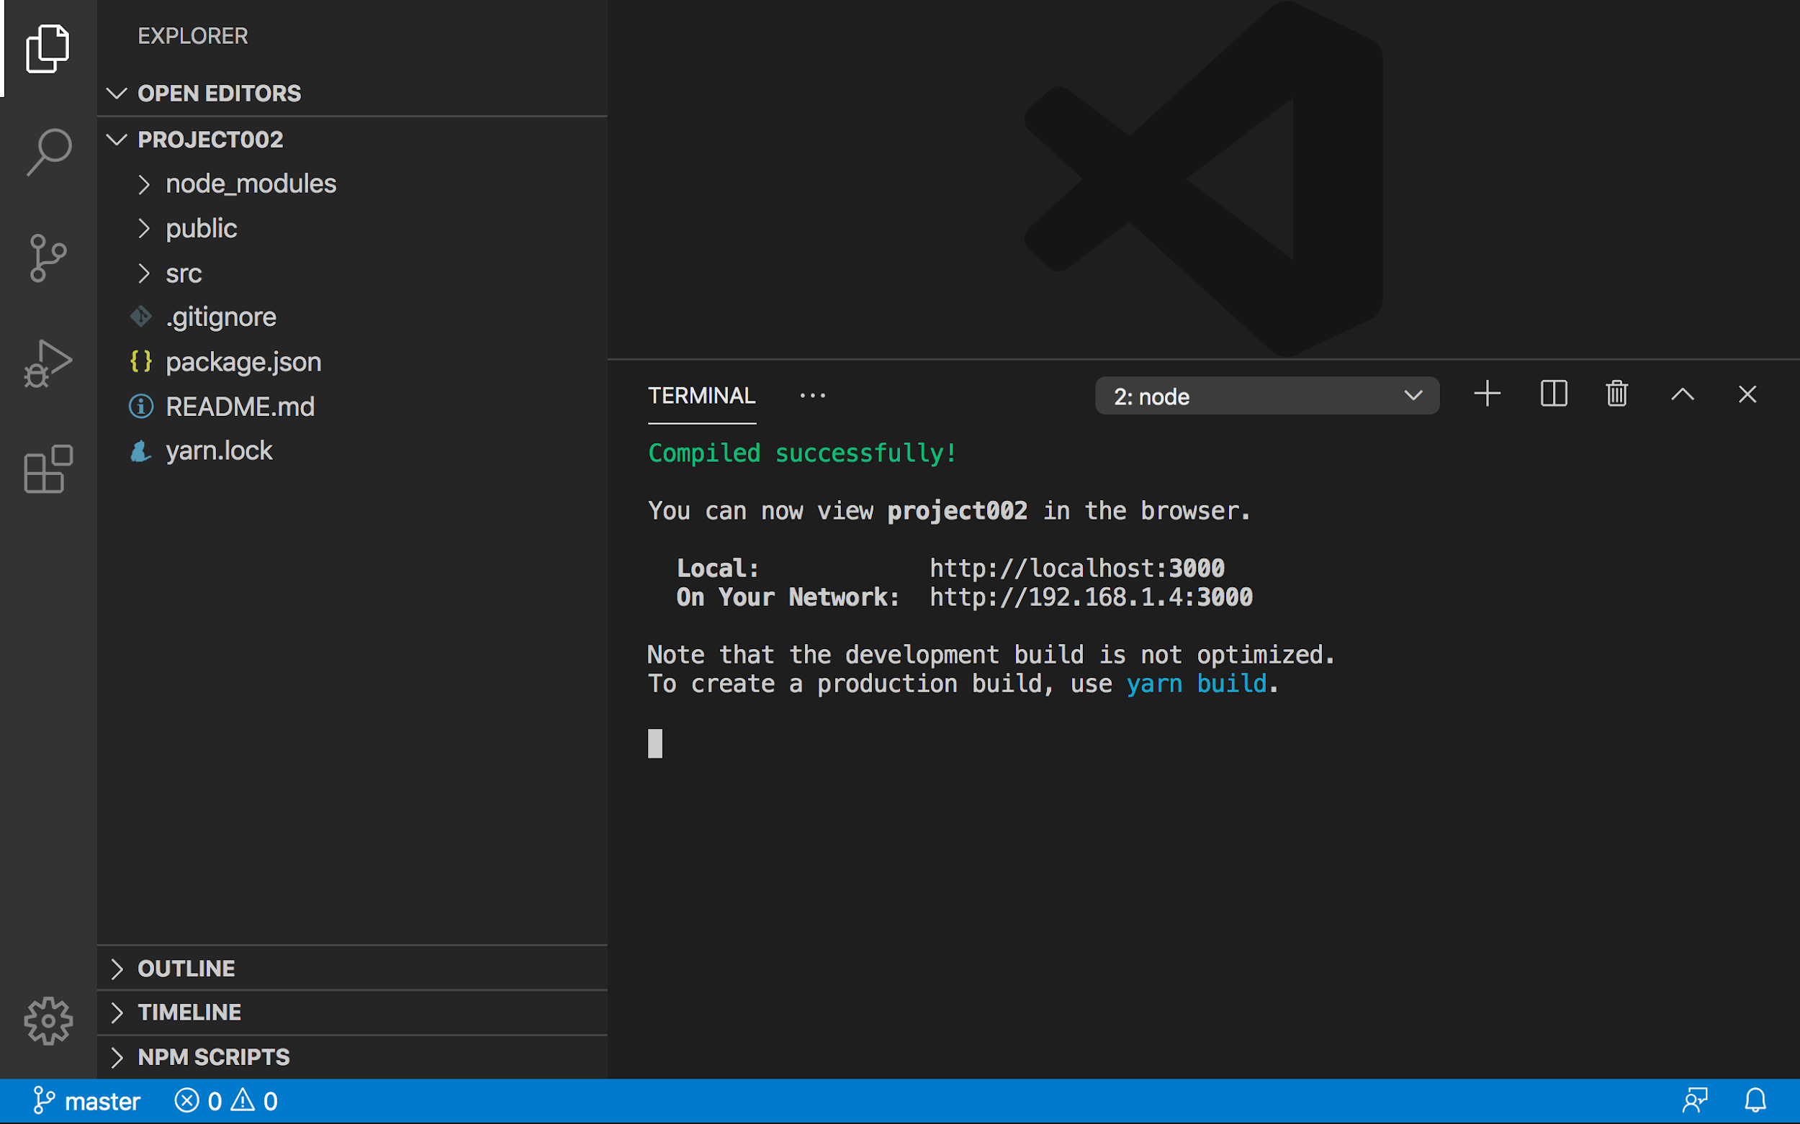

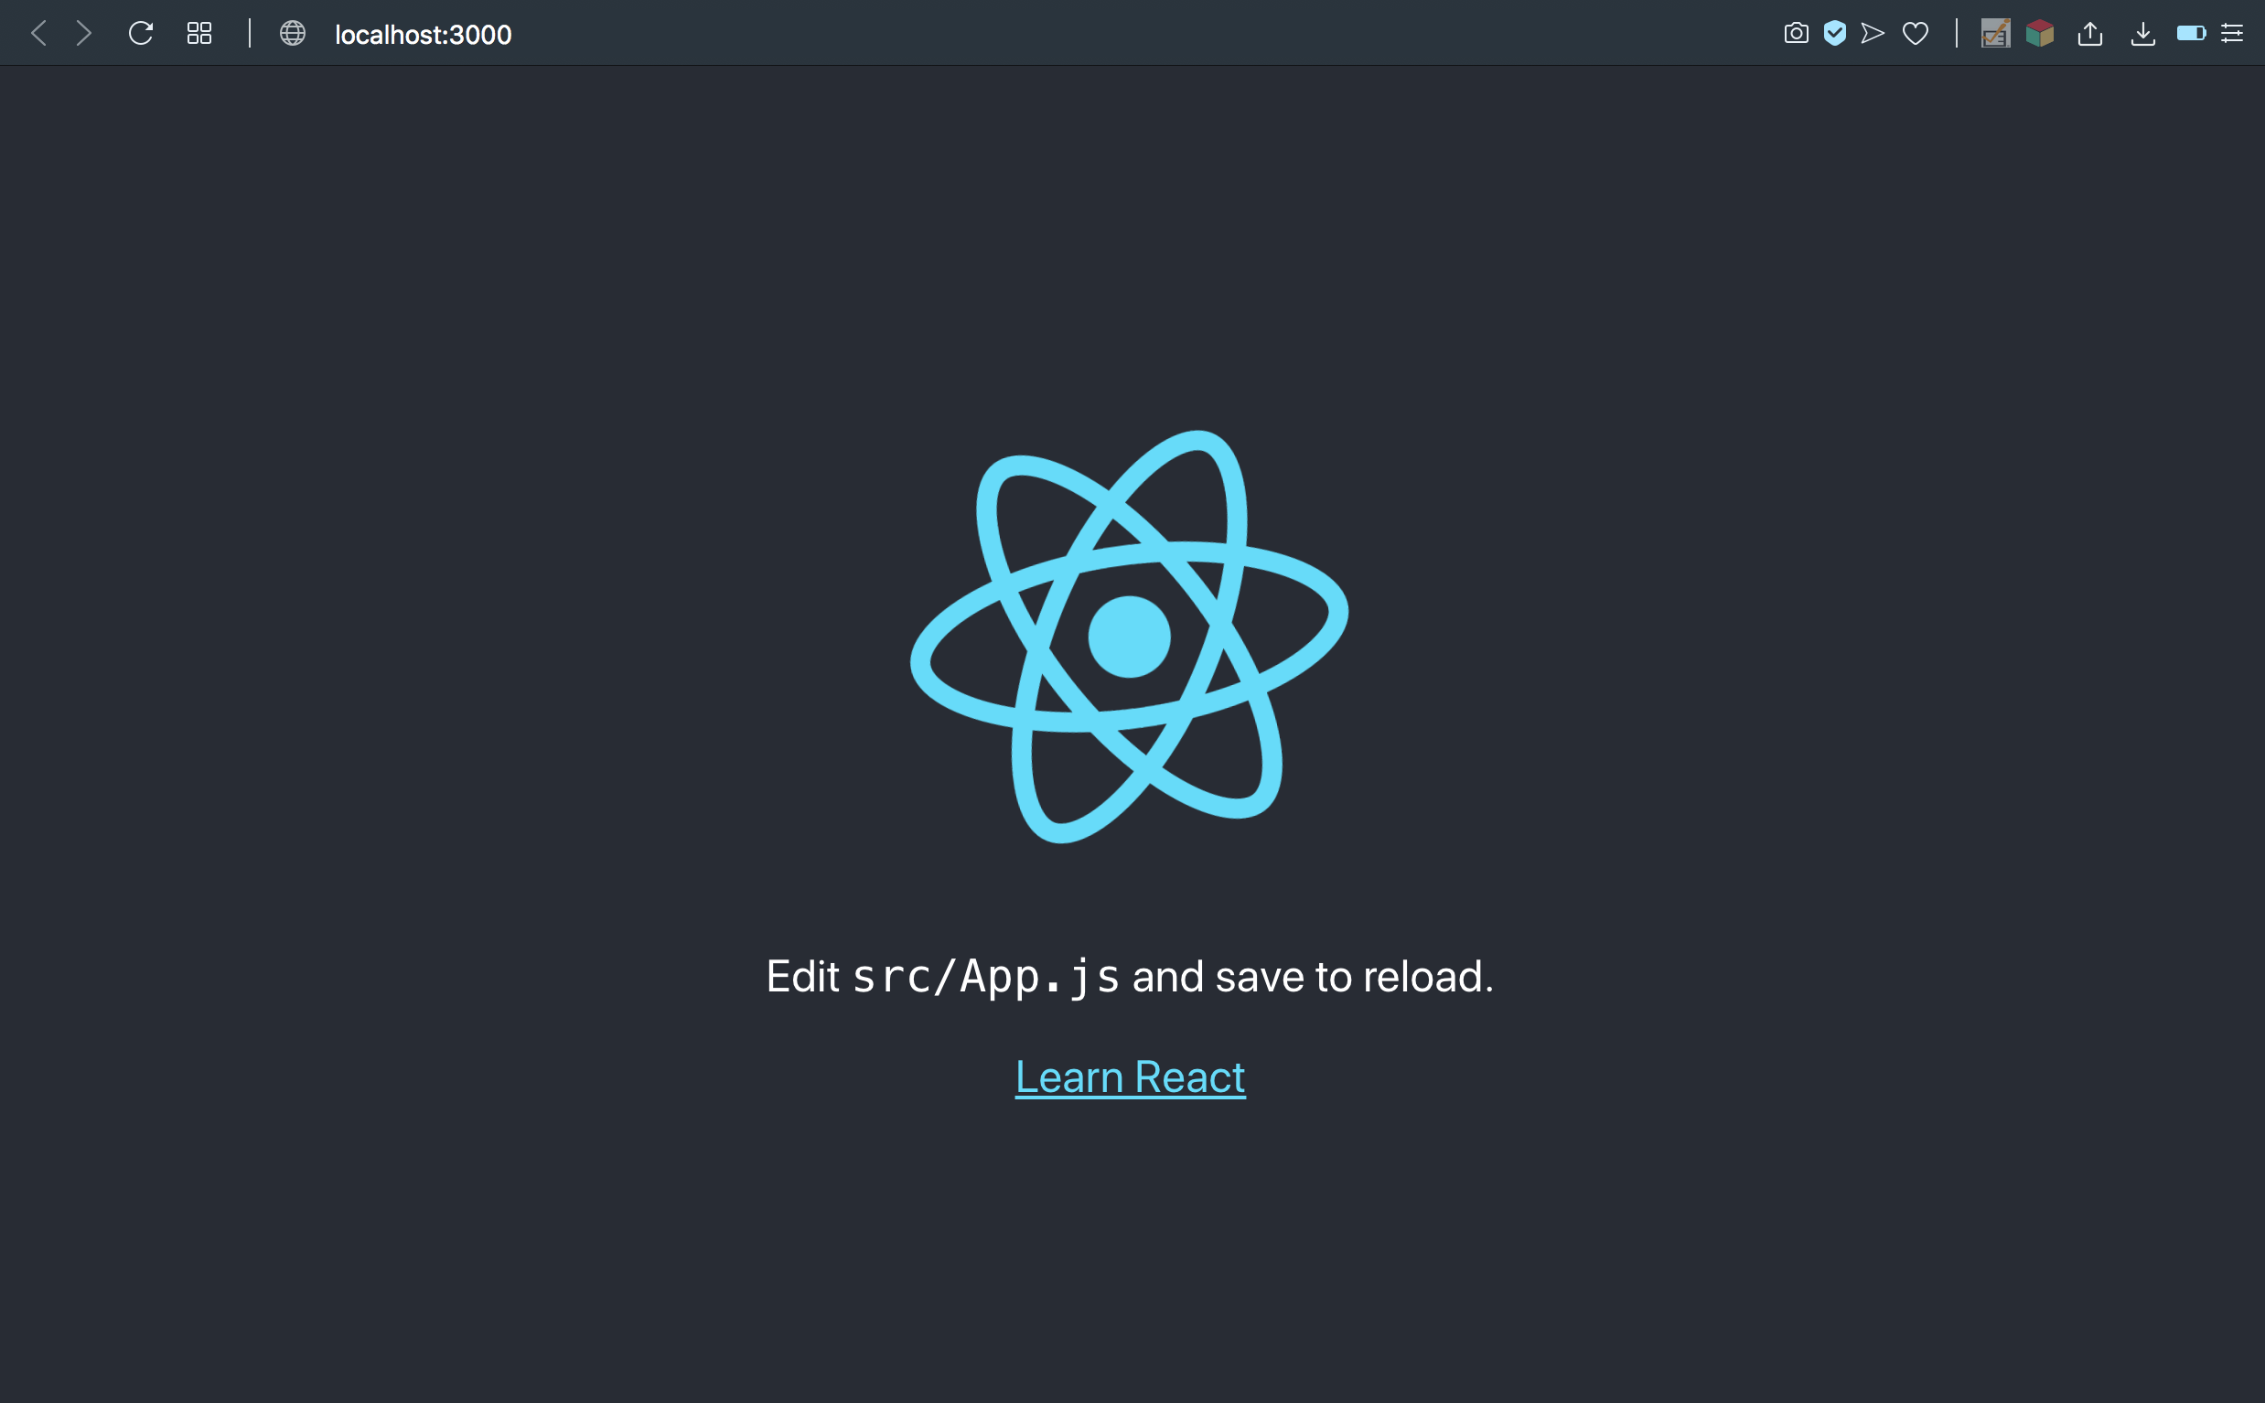

## Part IV - Add Repository to GitHub with the CLI

Step 1: Create a new repository on GitHub

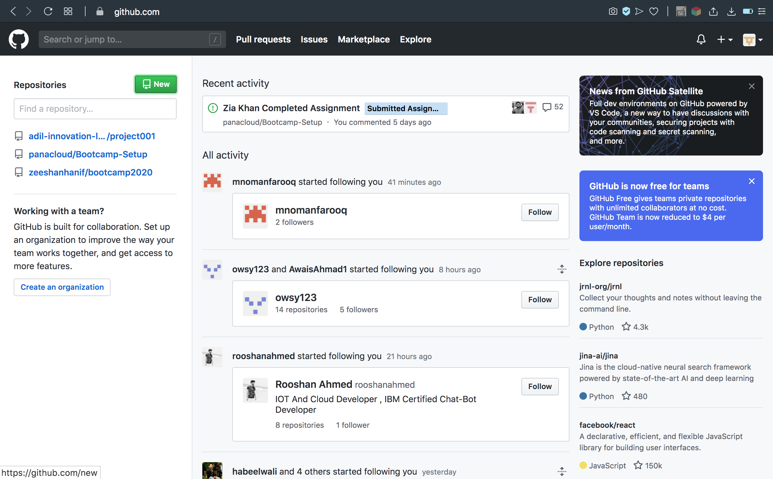

Do not initialize with a readme file, gitignore, or license:

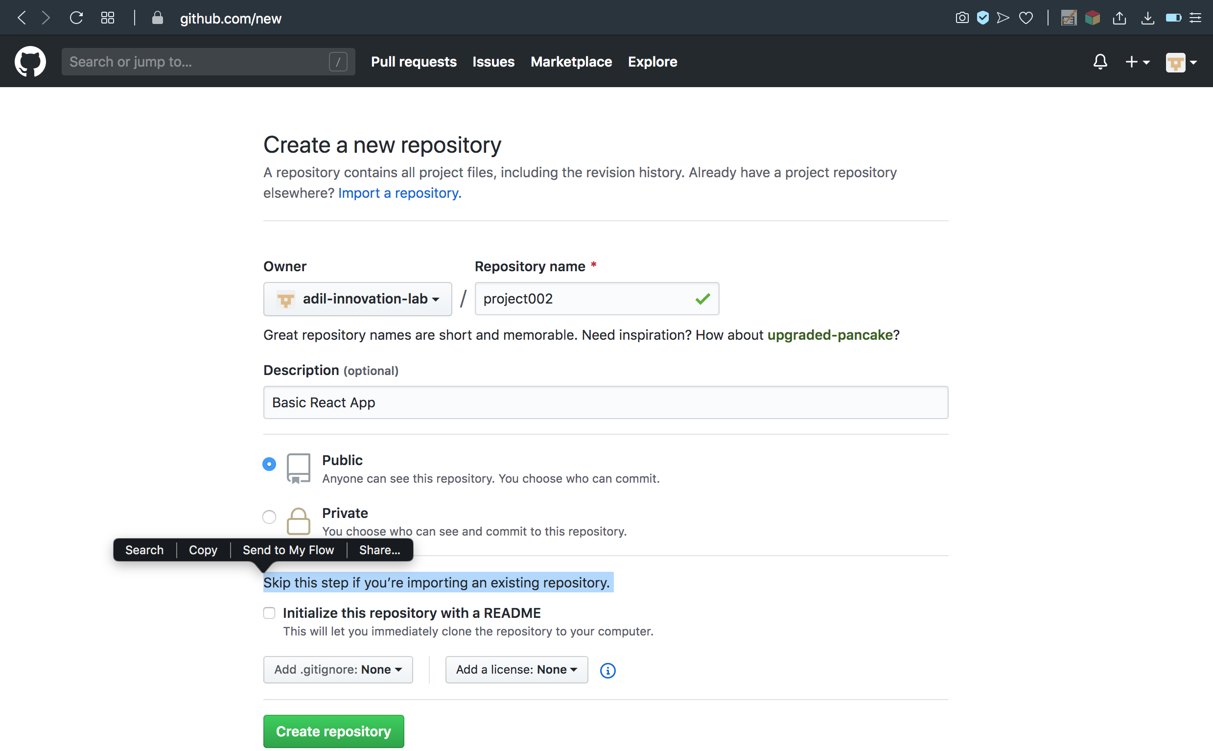

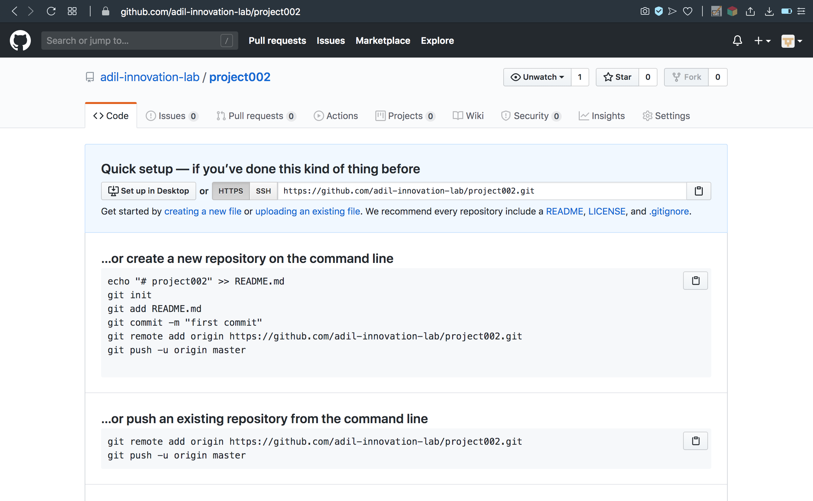

Step 2: Initialize the local directory as a git repository:

Open terminal in our local folder:



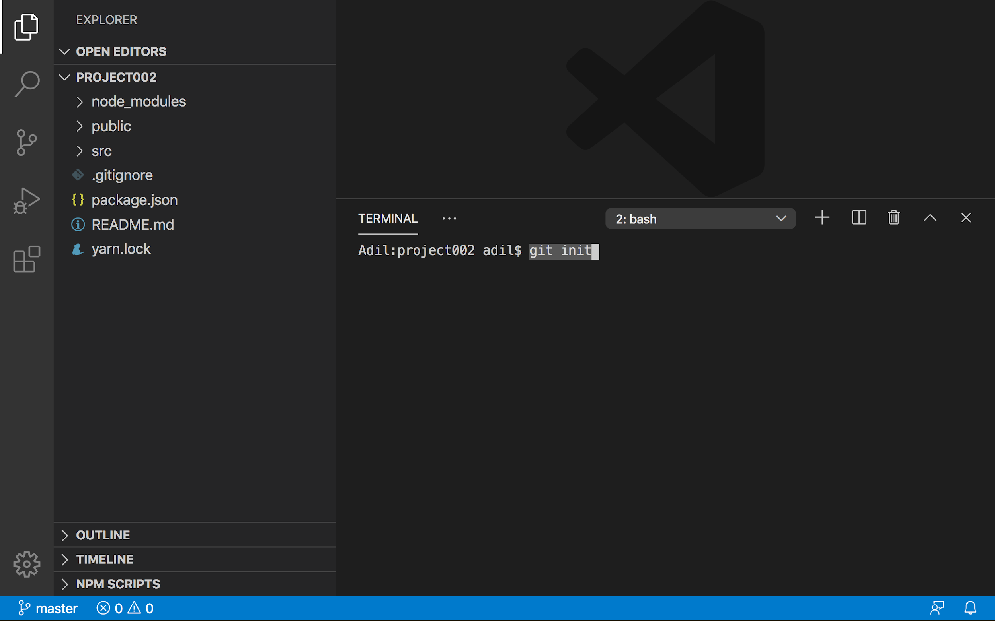

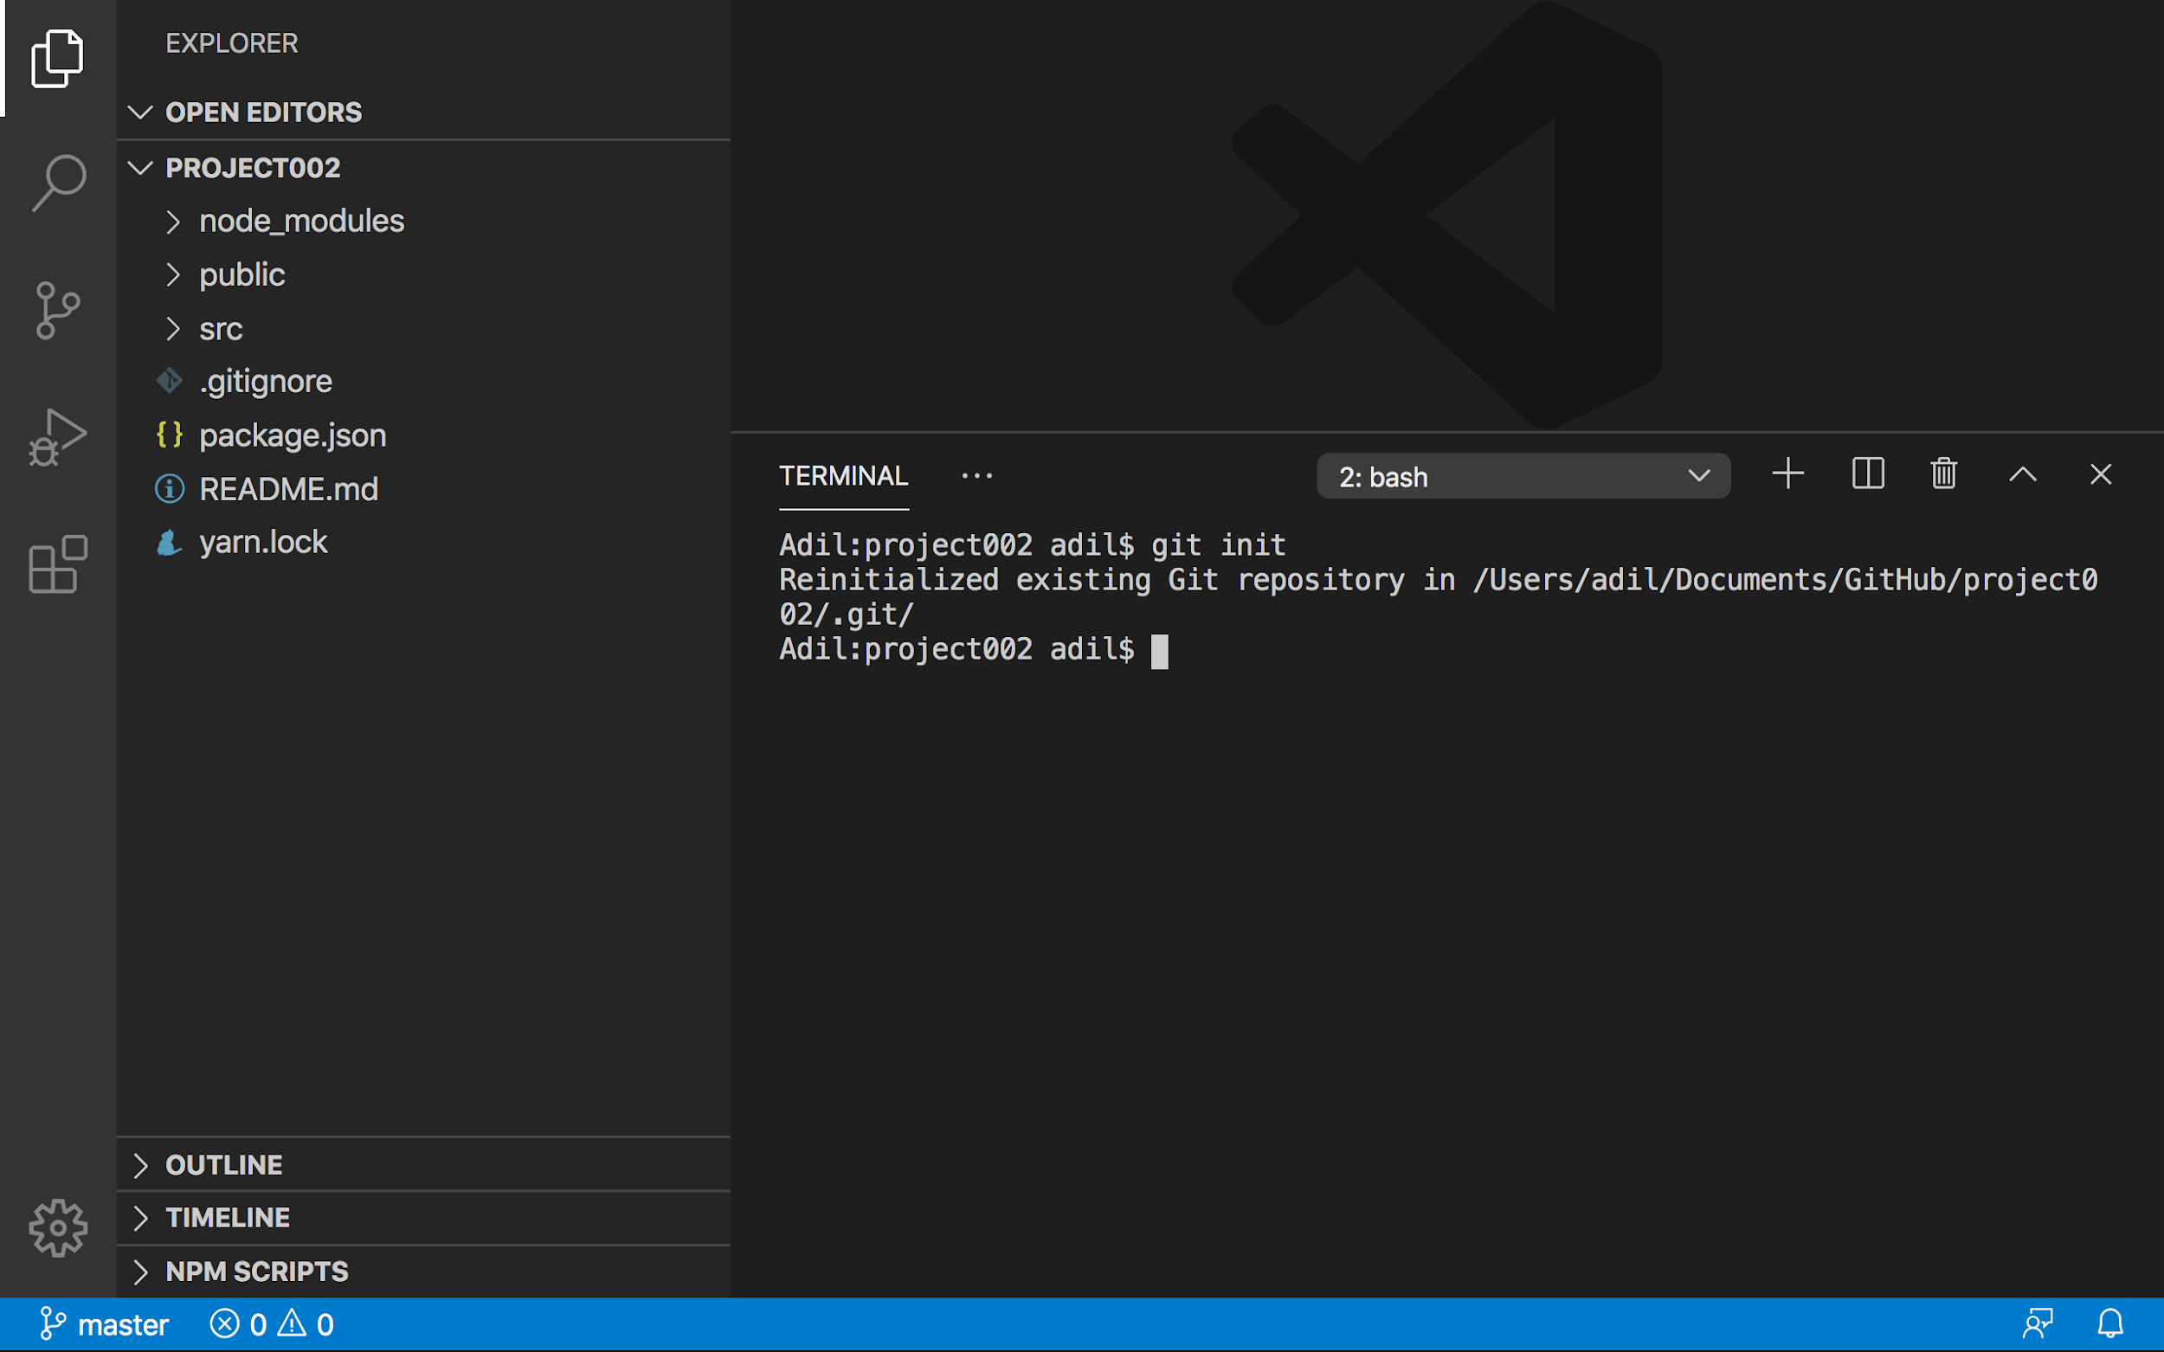

Step 3: Add files from local directory to git staging area to prepare for commit

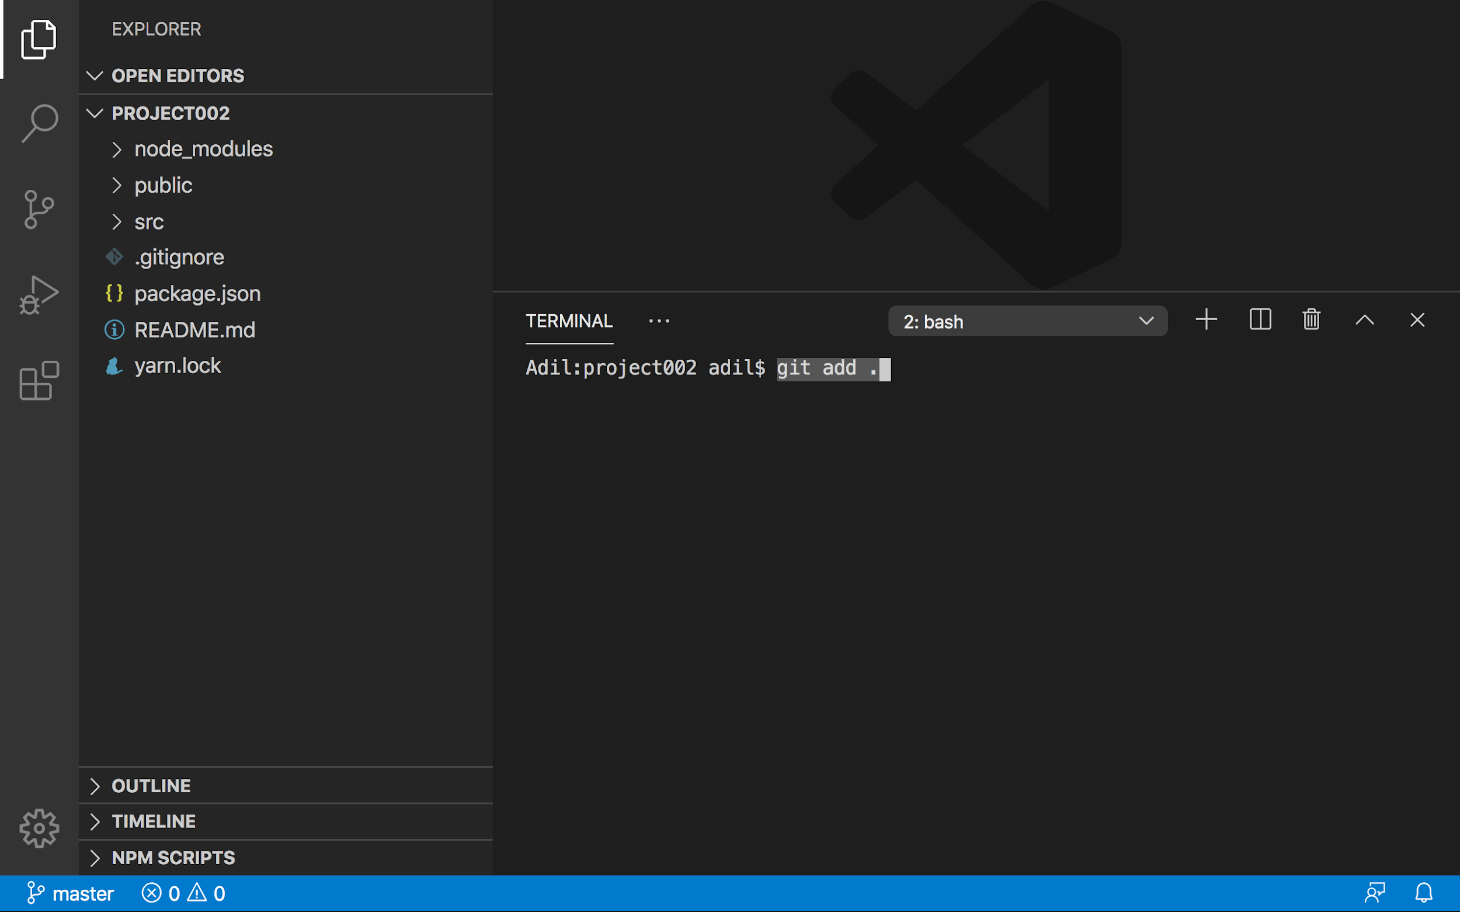

Step 4: Commit files from staging area to local git repository

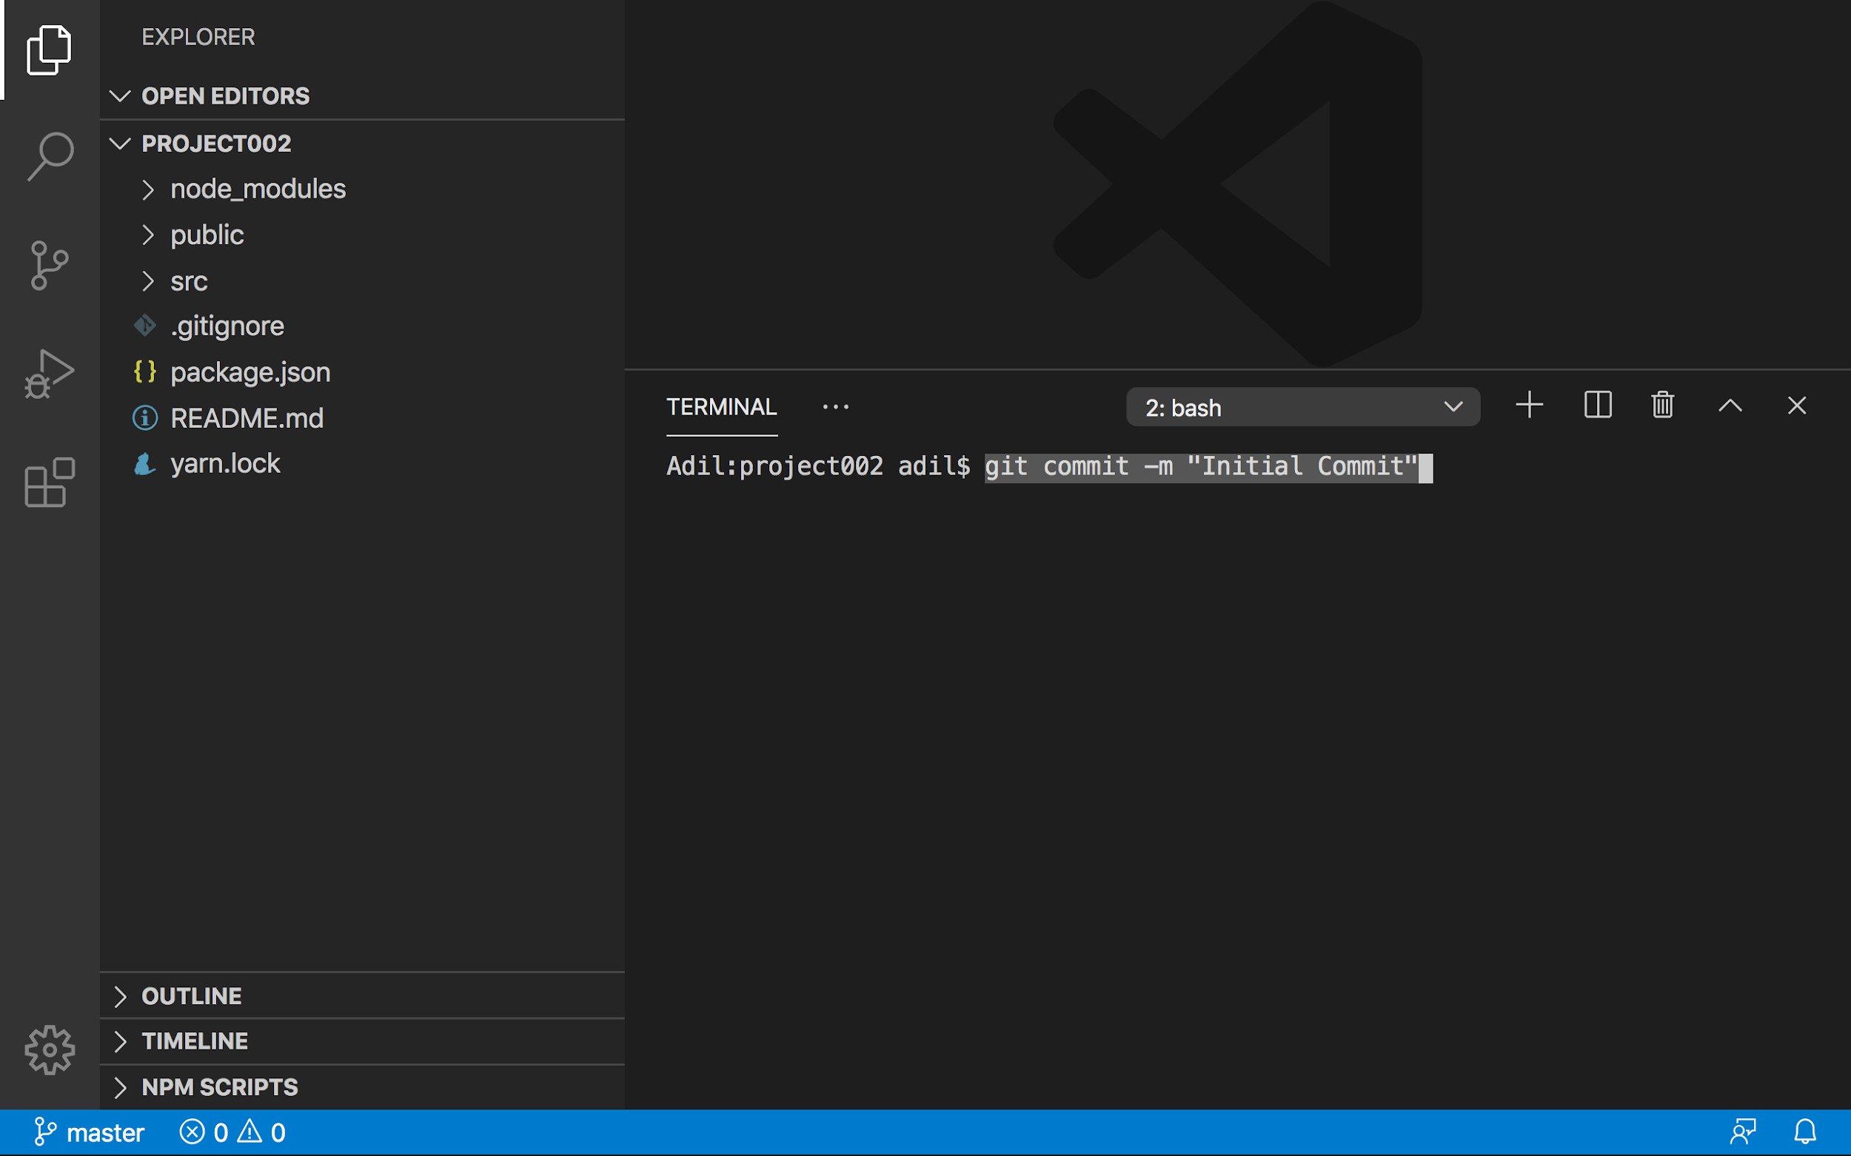

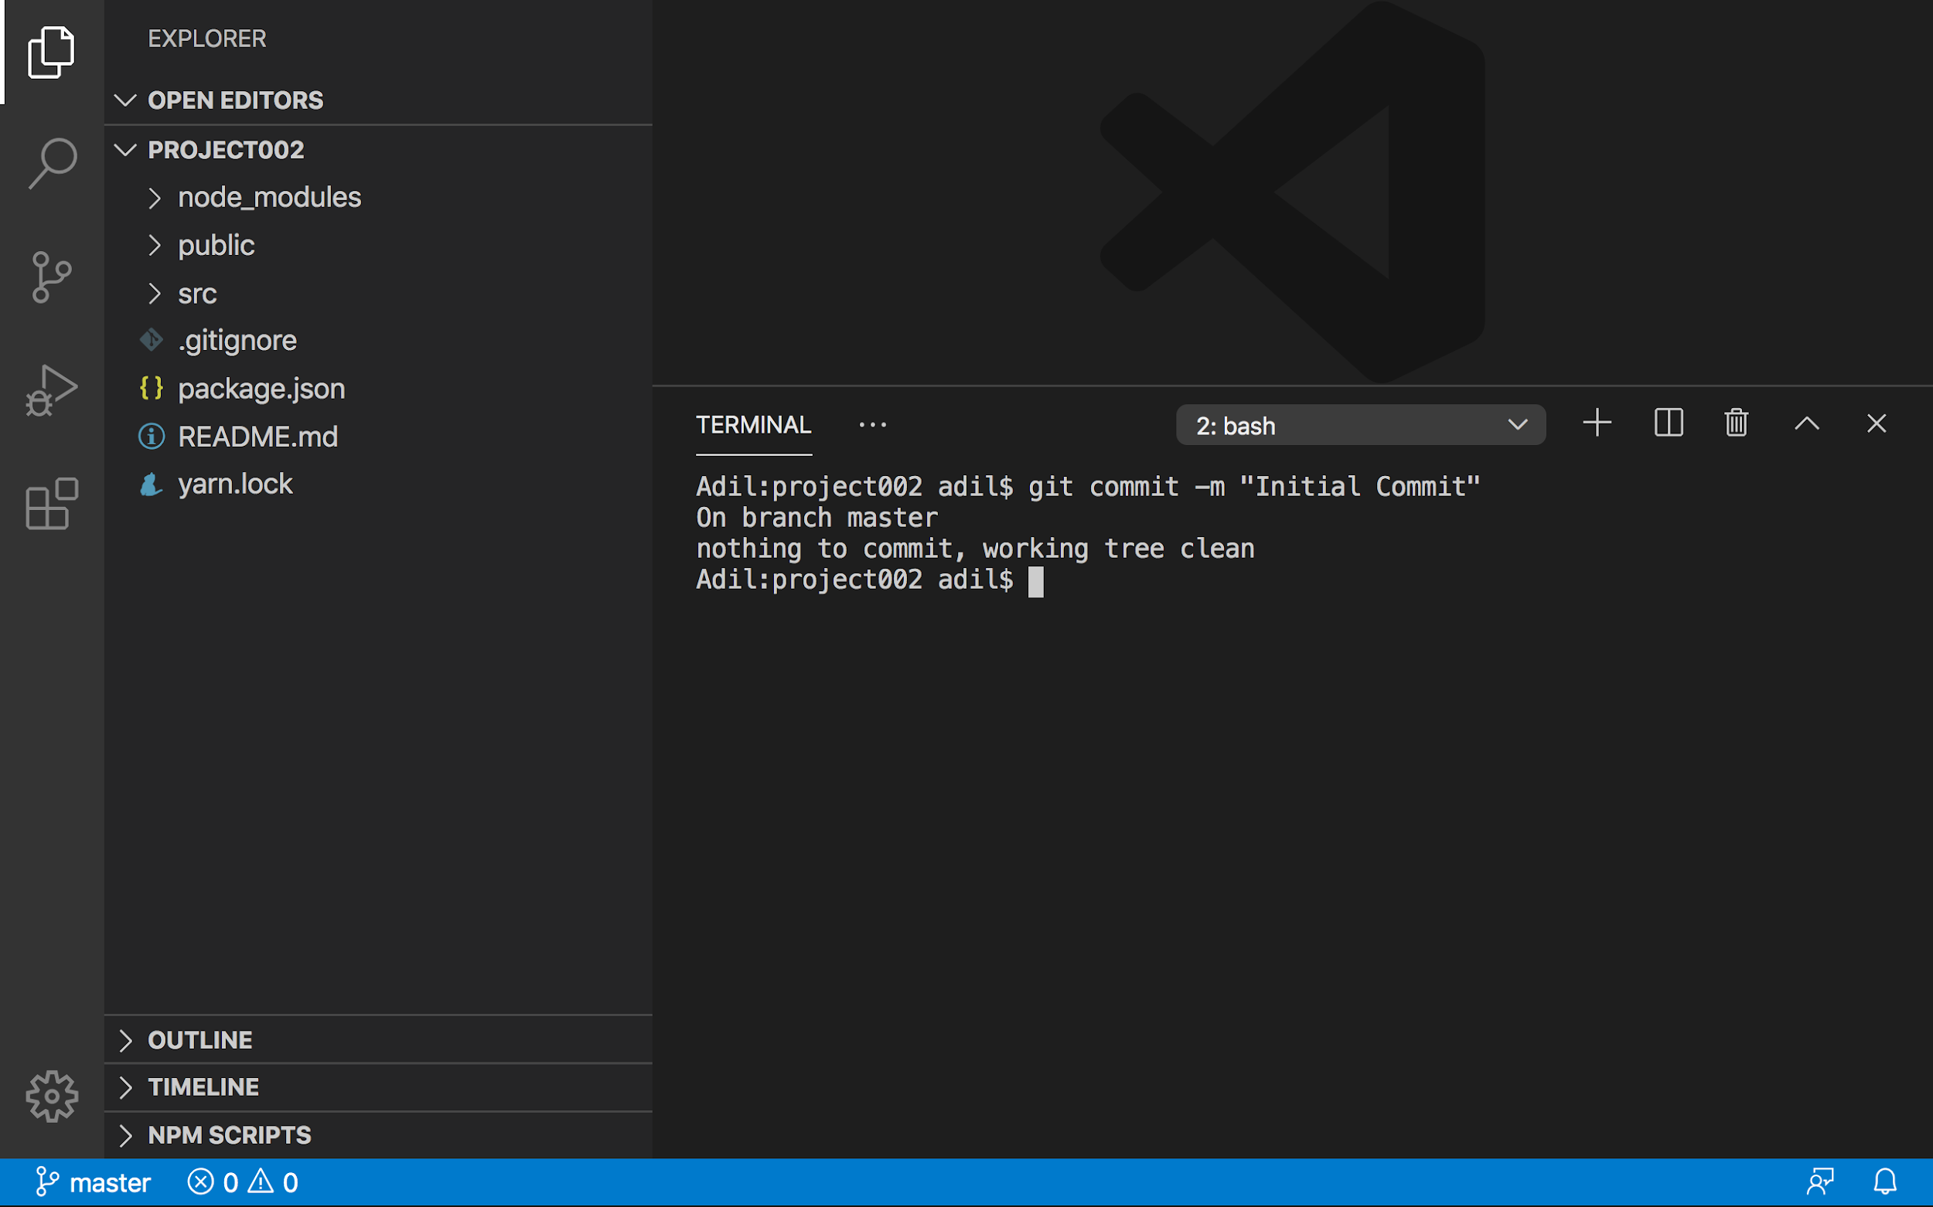

Step 5: Get the URL of the remote repository from GitHub:

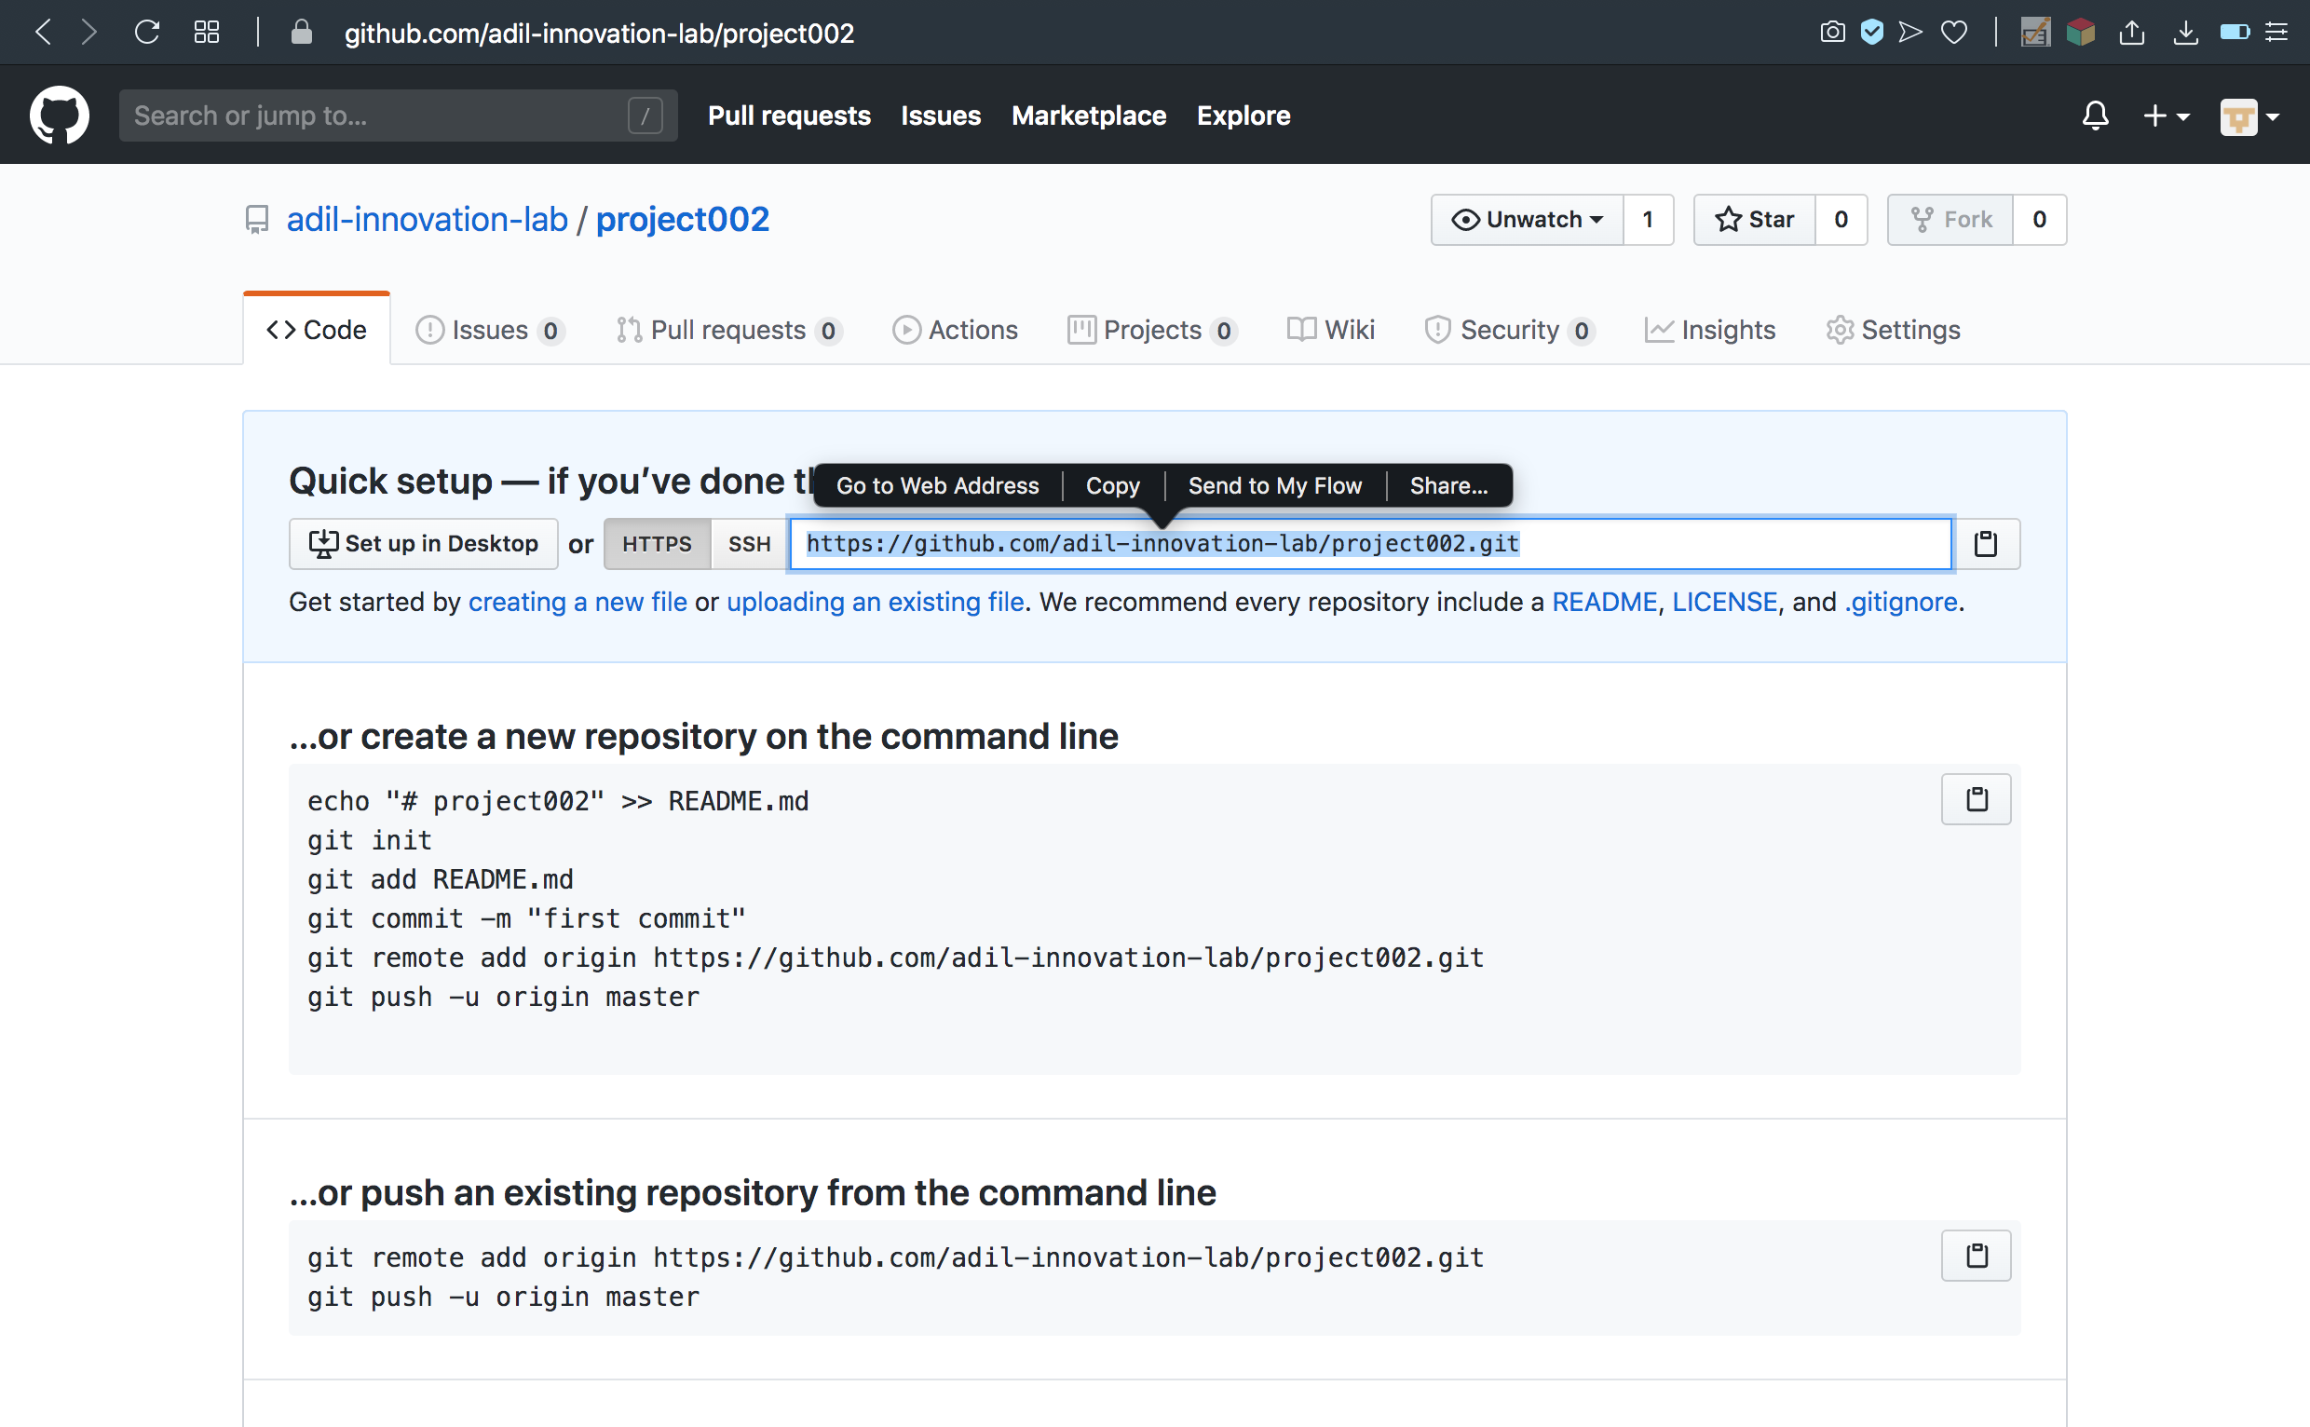

Step 6: Add remote URL to git via the terminal so local repository can be pushed to the right place

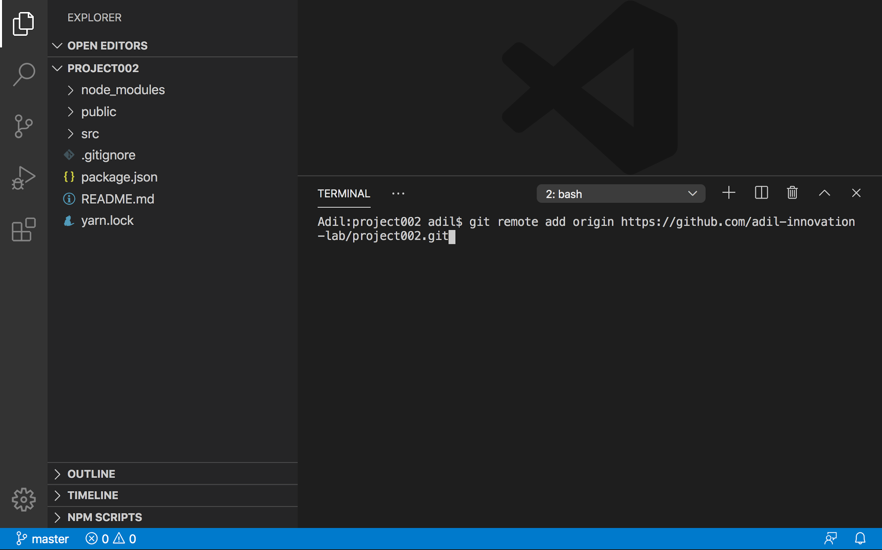

Verify the remote URL

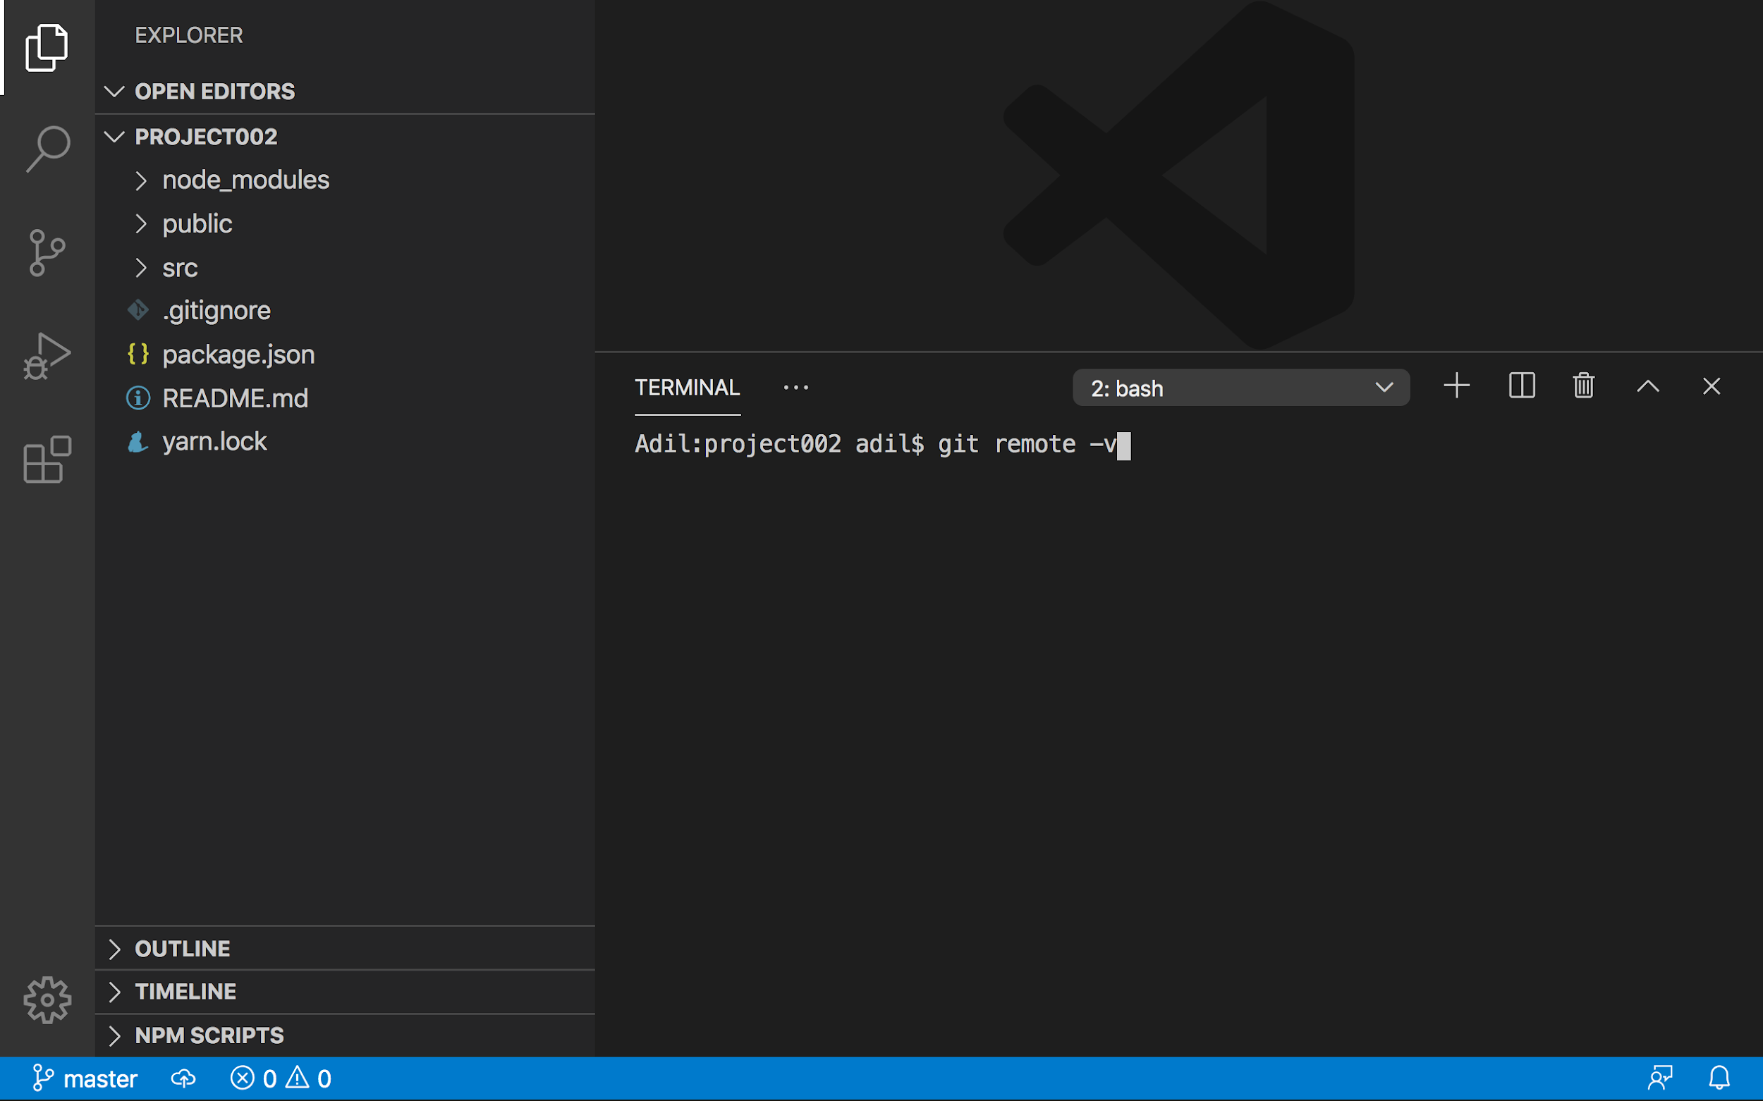



Step 7: Push the code from local git repository to the remote git repository

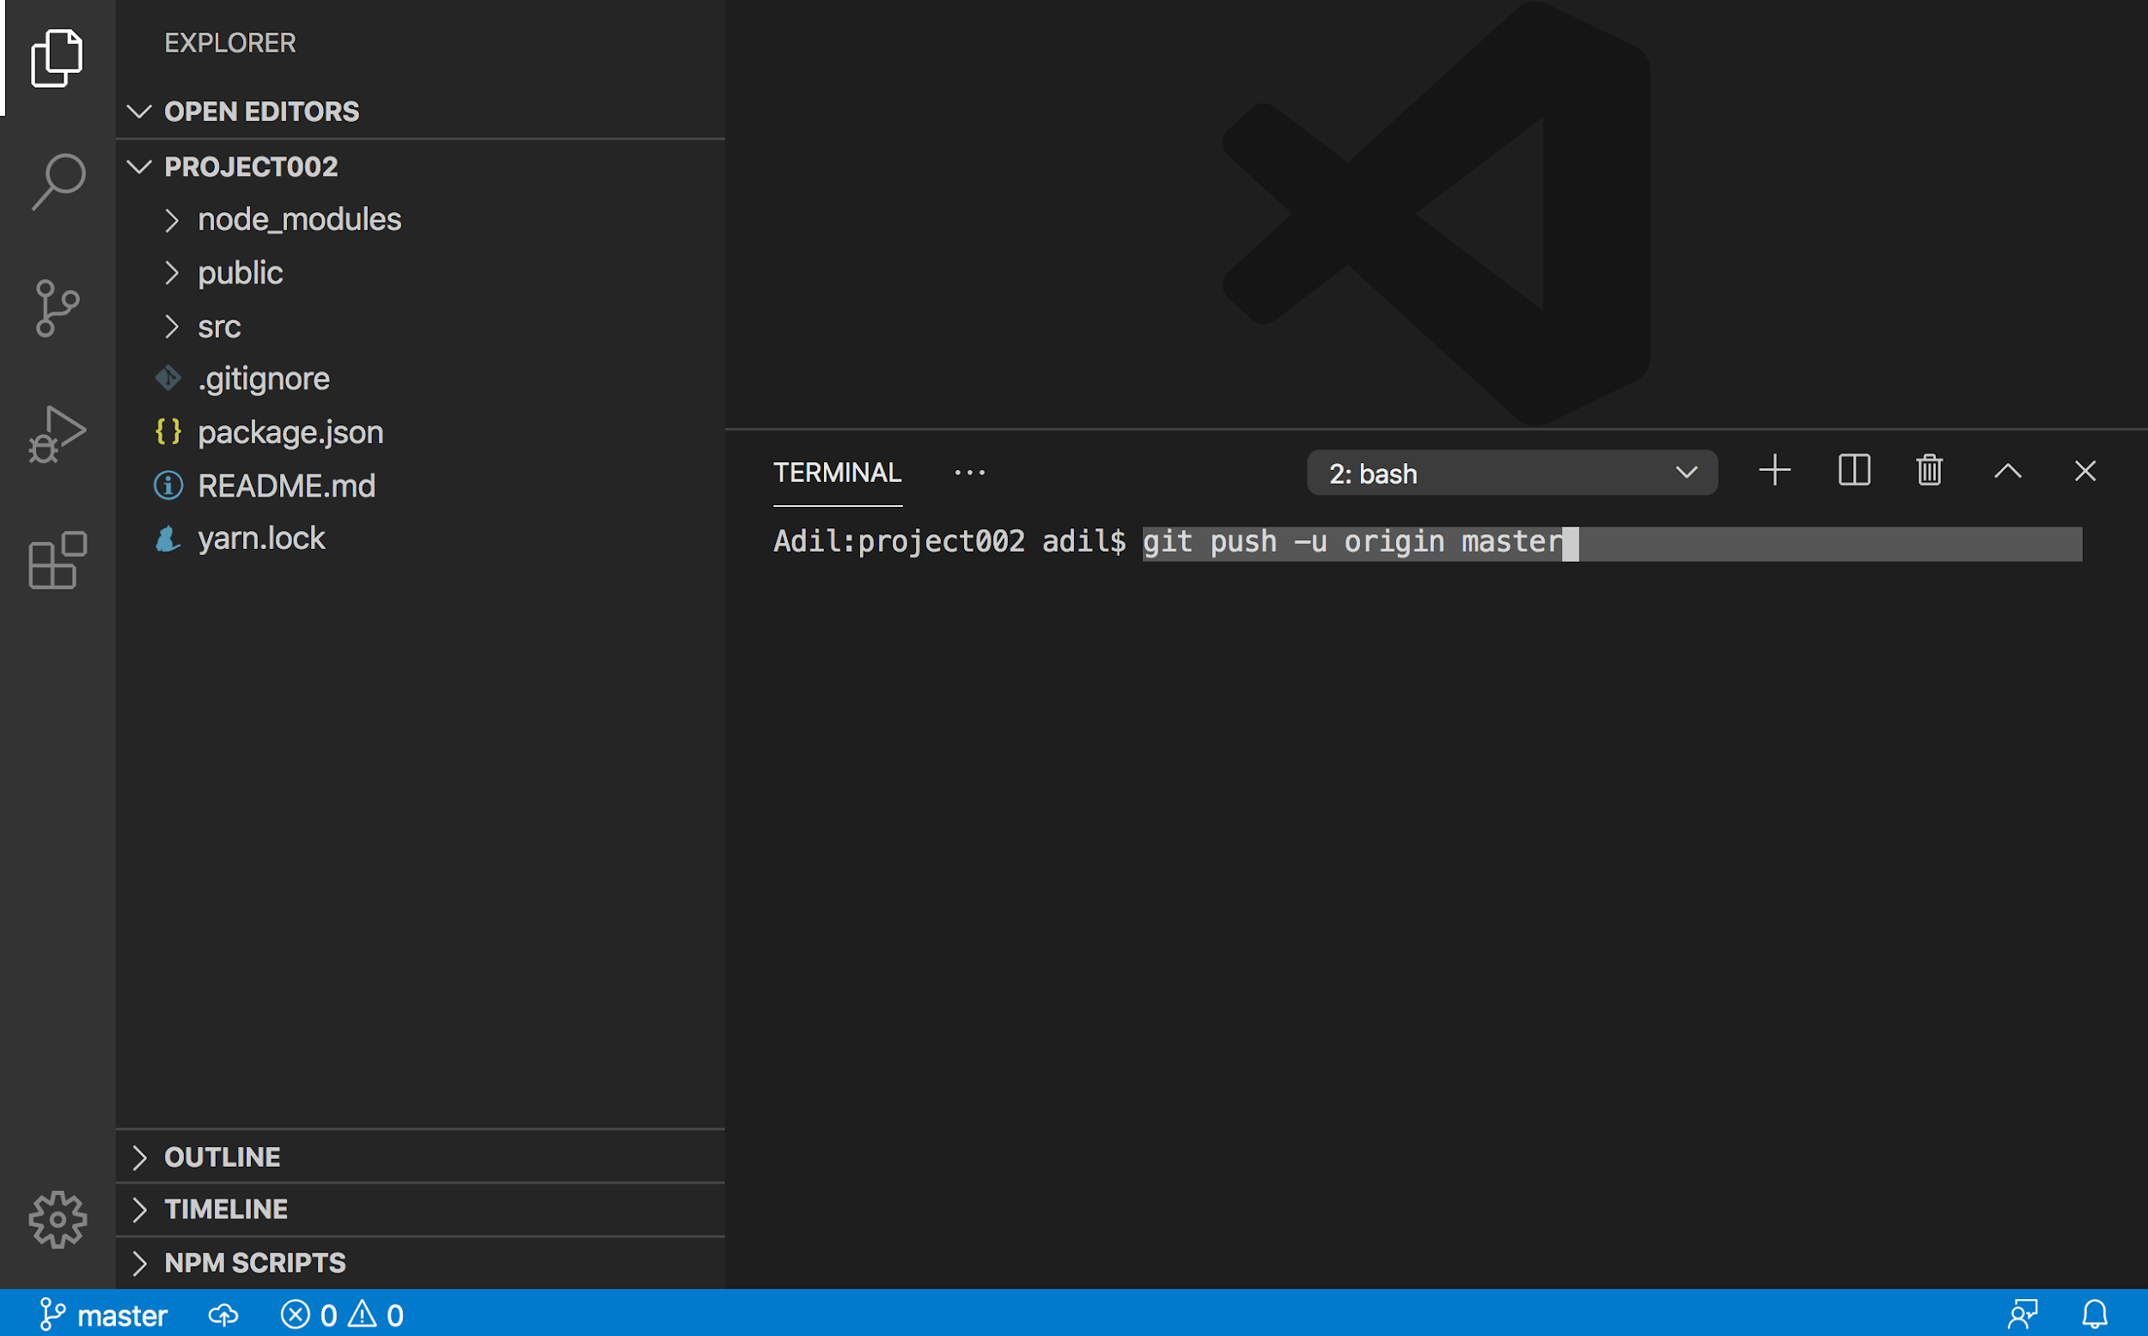

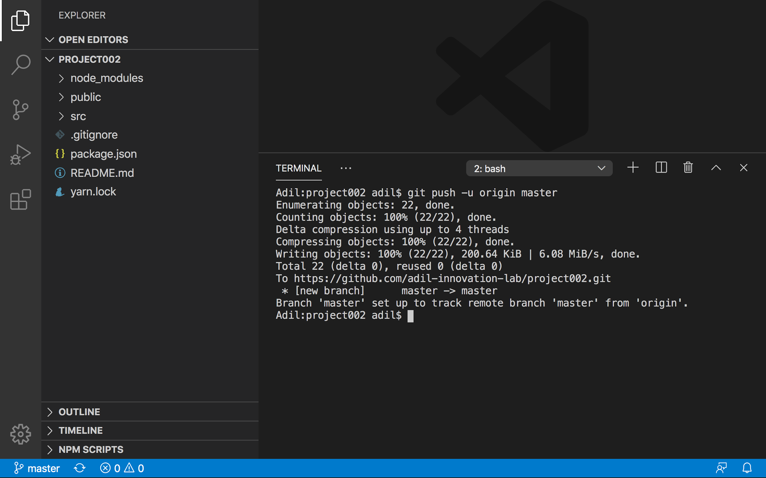

Step 8: Verify changes pushed to remote git repository

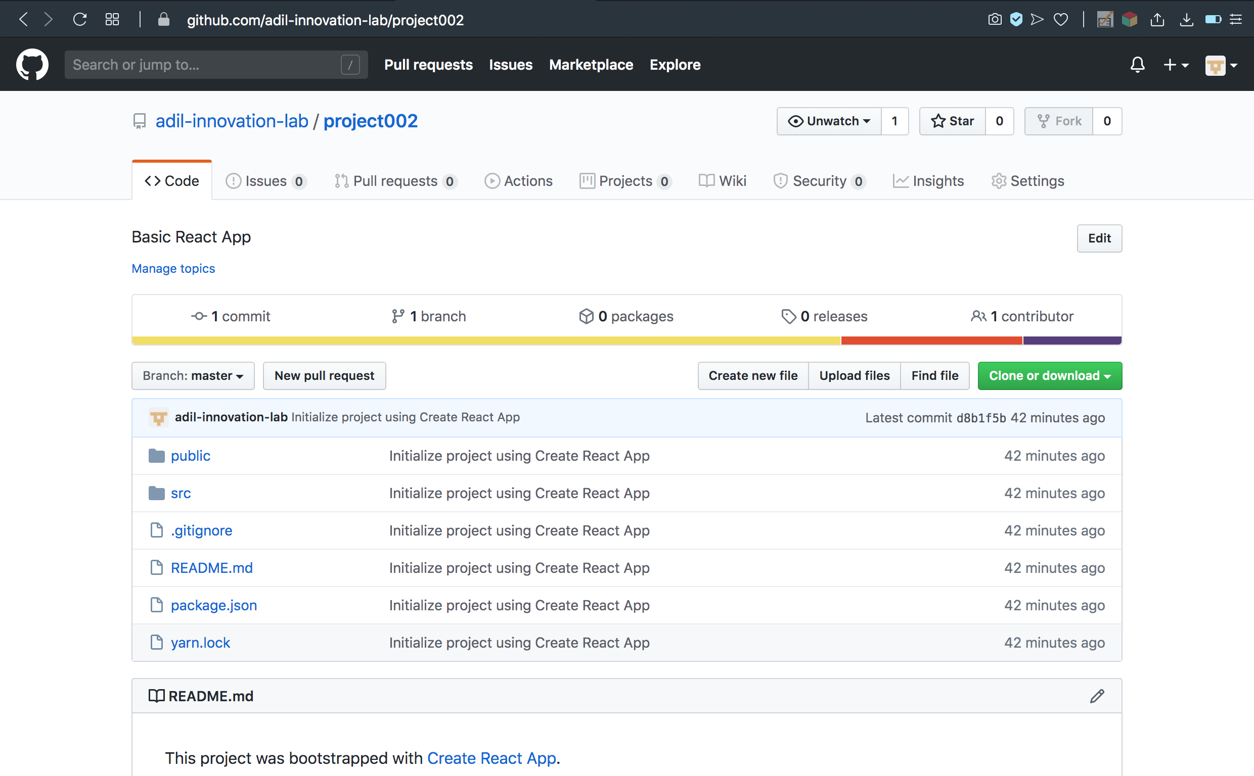

## Part V - Deploy React App to Surge with a GitHub Workflow

Step 1: Create surge token and add a secret to the GitHub repository

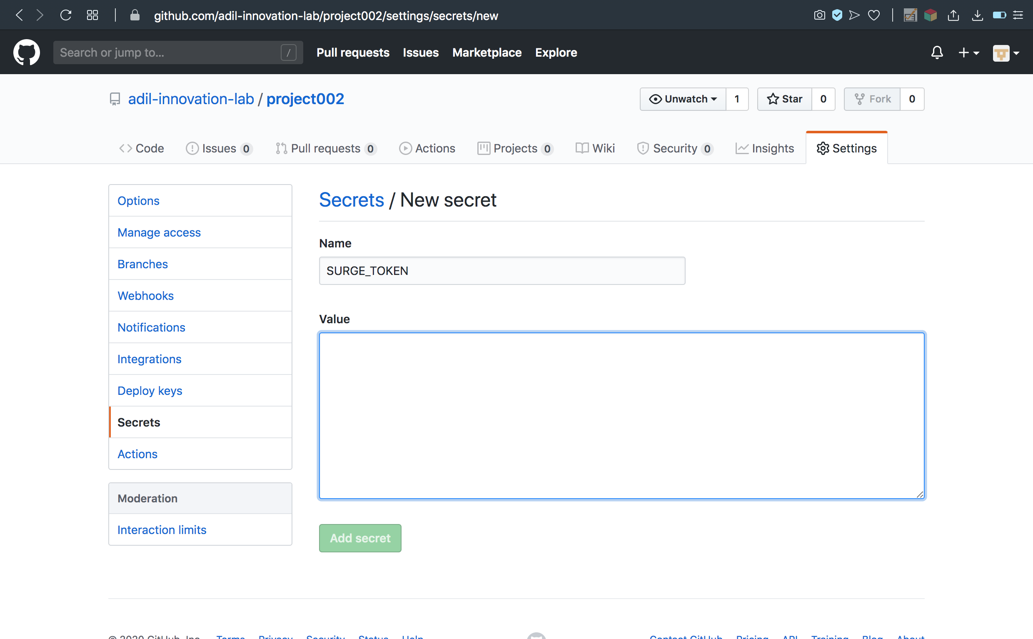

Step 2: Go to the Actions tab in the GitHub repository on github.com and click the set up a workflow yourself link

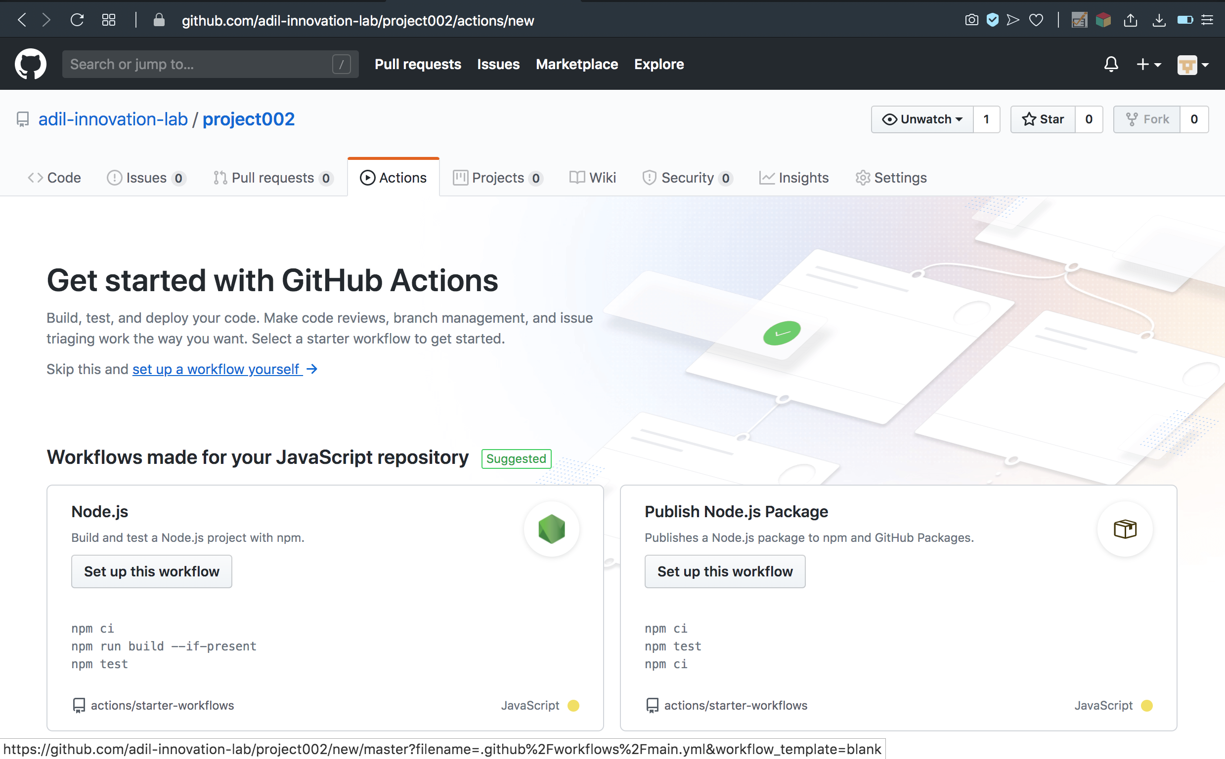

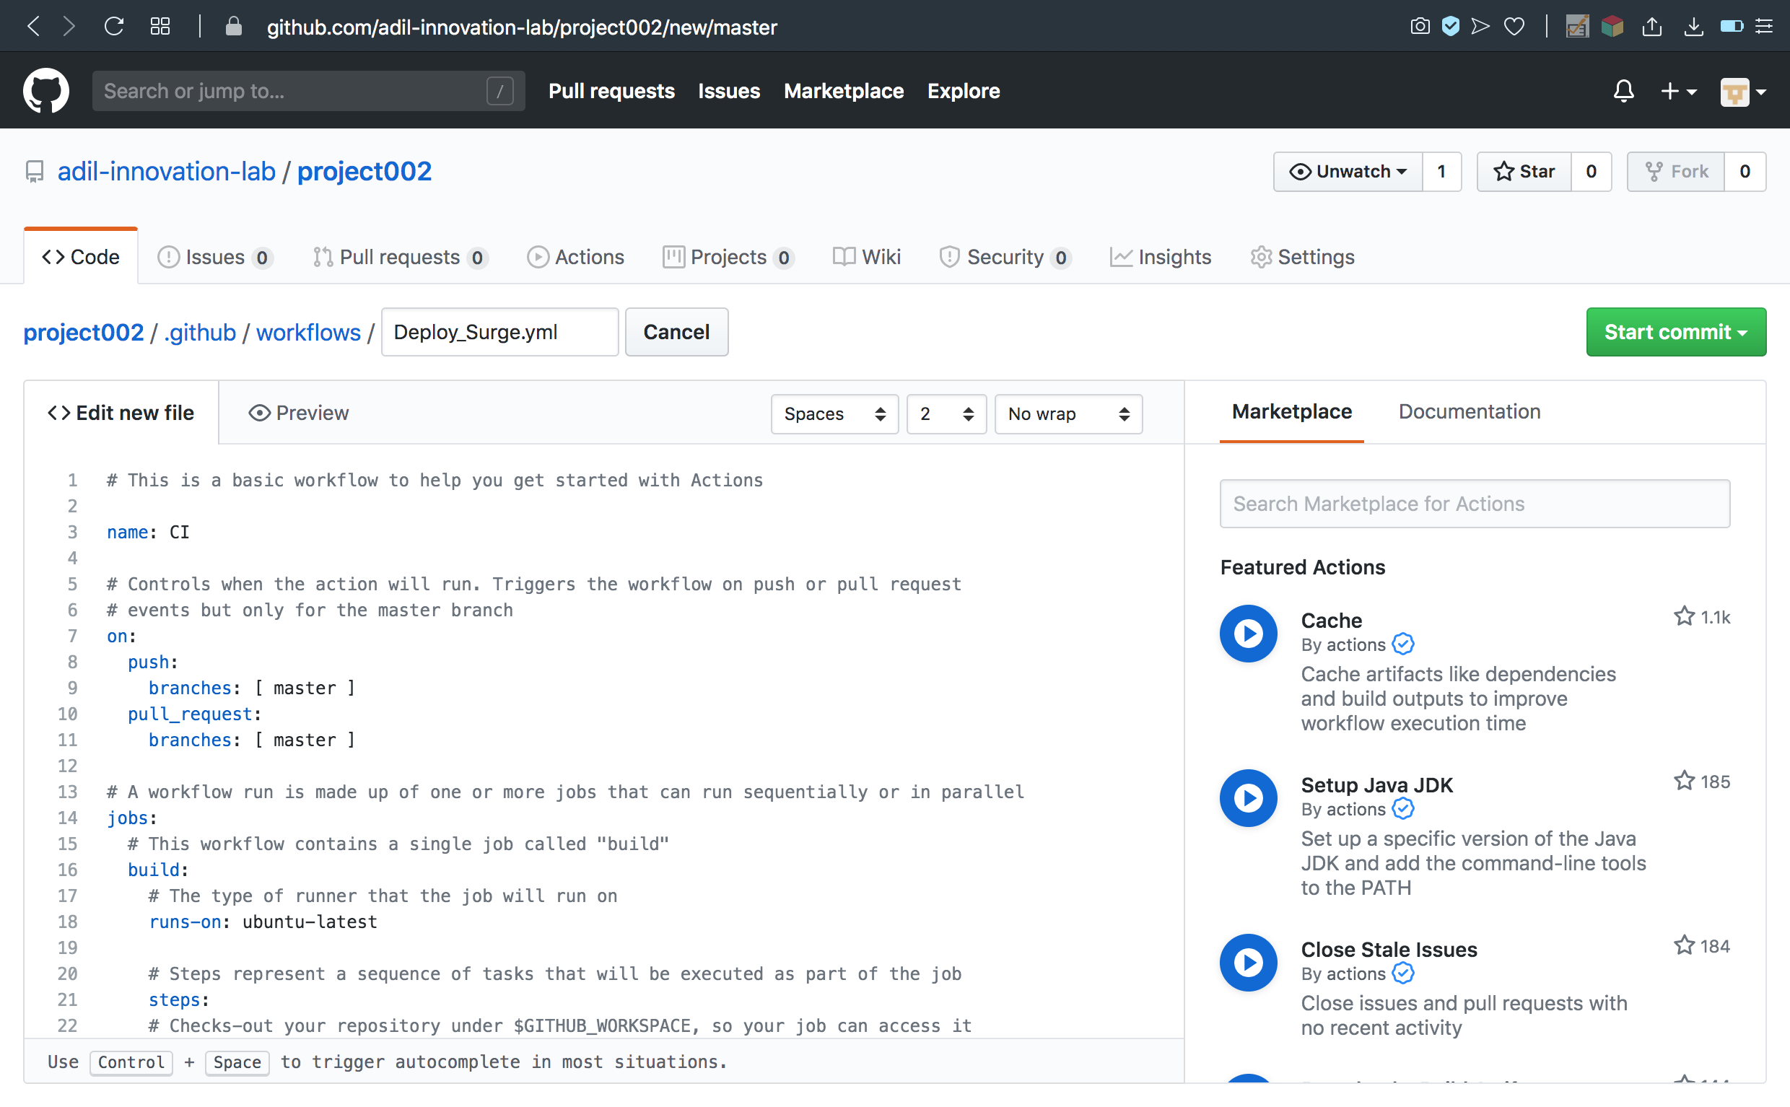

Step 3: Write the YAML for the workflow

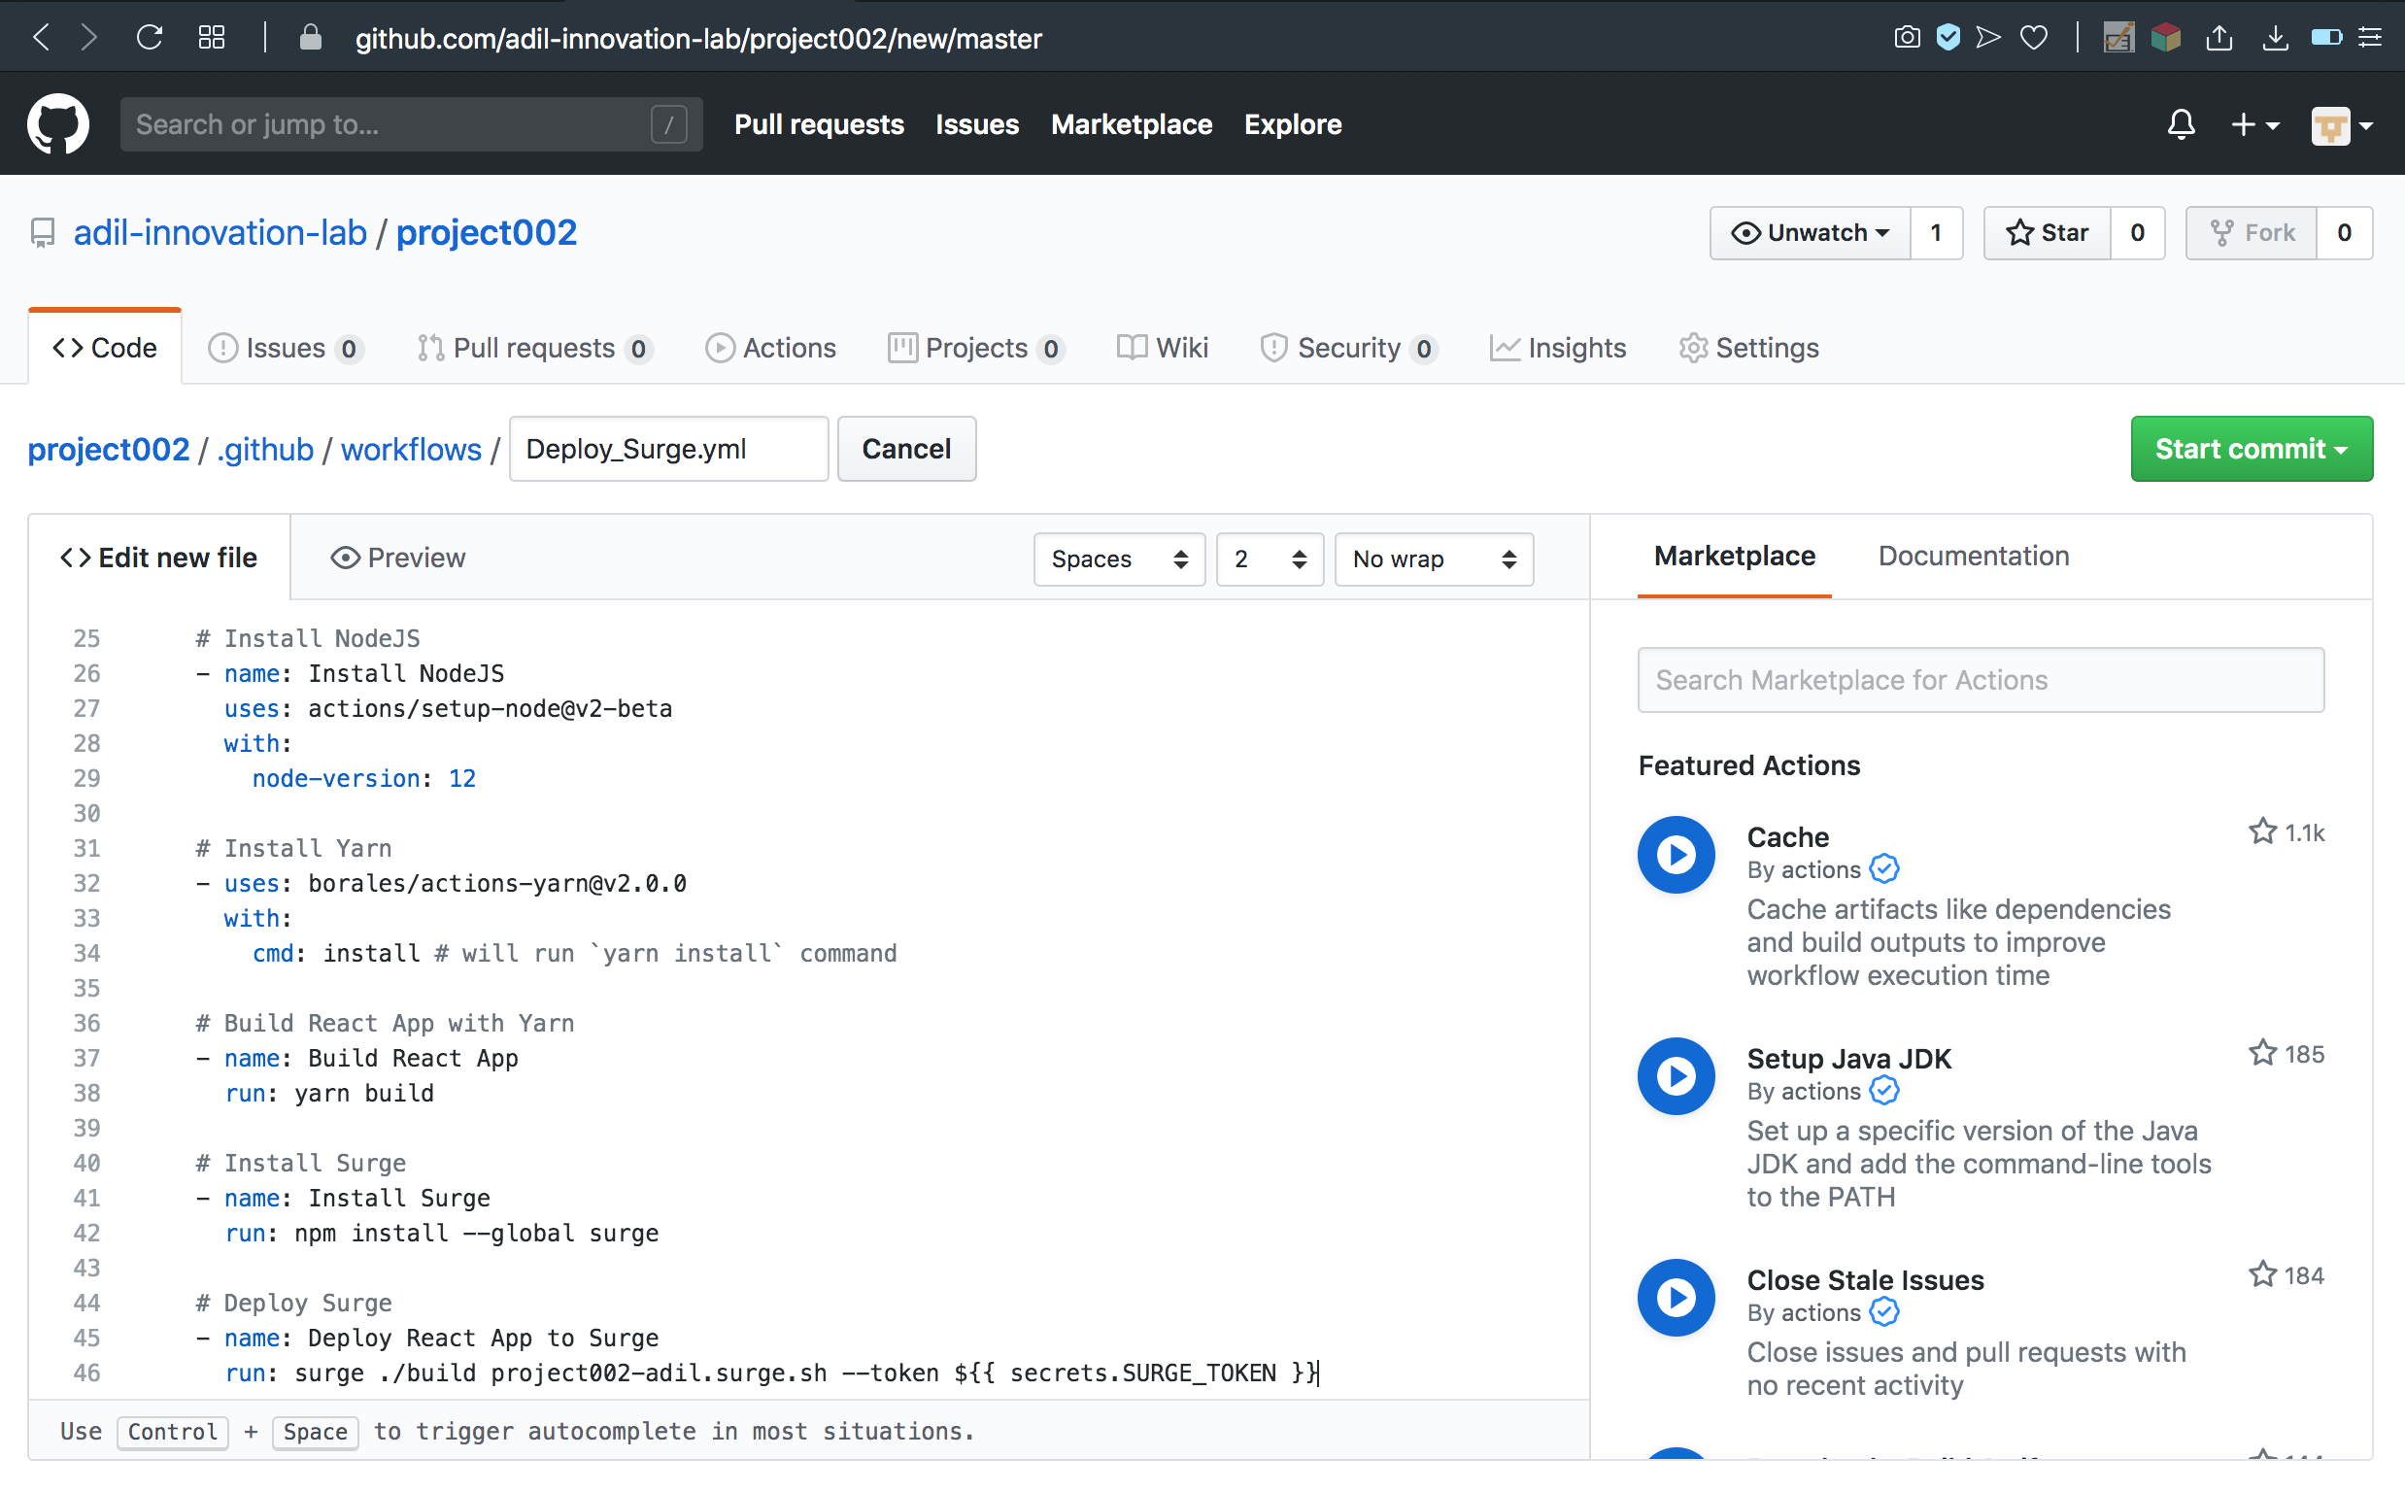



Step 4: Commit the workflow to the master branch

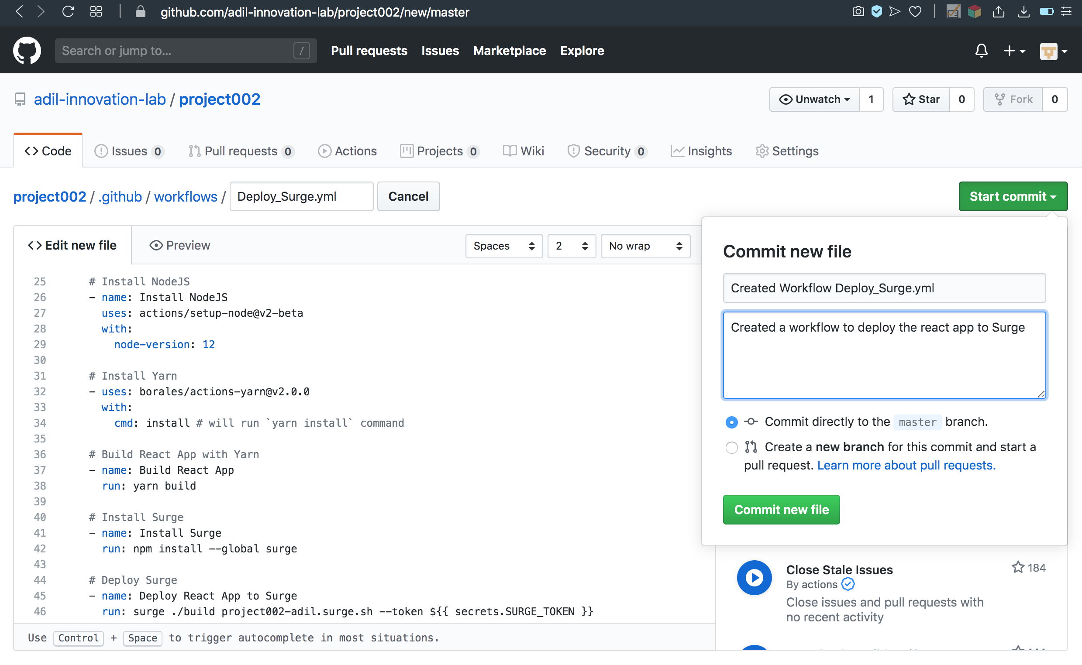

Step 5: Check the Actions tab for the workflow to deploy successfully

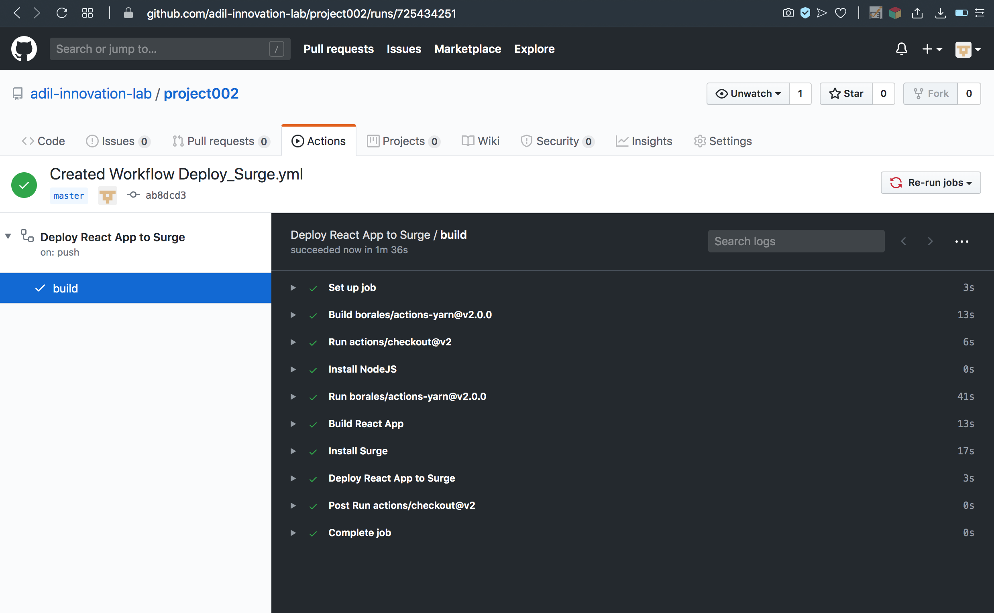

## Part VI - Learn React

<https://daveceddia.com/react-tutorial/>

## Part VII - Report Project Completed as an Issue

